Brand Alliance Effectiveness in the UK Liquor Industry: Understanding Consumer Perceptions of Brand Fit and Purchase Intentions

Final submission
Name: Krishna Bajaj (K2461178)
Course: MSc in Marketing and Brand Management
January 2025 to January 2026
Word Count: 9562

Abstract
This paper examines consumer perspective towards brand alliances, and the impact on the purchase intention in the liquor industry in the UK. It employs the Theory of schema congruity, theory of associative network of self-congruity to establish how the cognitive schemas, memory association and identity congruency affect the revision of real and hypothetical partnerships. It was a qualitative, interpretivist based grounded theory study design that comprised 10 semi-structured consumer interviews and 04 expert interviews. Data analysis consisted of open, axial and selective coding, identifying main themes: consumer preferences and consumption trends; brand intimacy and trust; brand-fit assessment; risk management of a partnership development; significance of the values in acceptance of alliances. Findings suggest that there could be authenticity, strategic, and functional fit, open communication, and alignments to consumer values are the main priorities of the effectiveness of the alliance. Not only does the paper have a basis of theoretical implications regarding the extension of alliances structure to the liquor industry, but it can also be utilized as the foundation of developing alliances that appeal to the UK customers and establishing brand equity.

Acknowledgements
I would like to express my sincere thanks to my supervisor, Professor Jagannadha Pawan Tamvada, because of his constructive advising and comments during the course of this research. I would also like to express my gratitude to the experts in the industry and UK consumers, who kindly took their time and volunteered information in the interviews. I thank my peers and the university ethics committee and their help they provided in the assurance of rigorous and ethical research practices. Lastly, I want to thank my friends and my family in letting me go through with this project and encouraging me.

Declarations
I do declare that the dissertation herein submitted is a composition of my own and that it has not been, nor will be produced by me elsewhere in any form with intent to secure any academic award. All the sources used are cited in the reference list and no direct quote is forgotten. This research study followed the university ethical rules and made informed consent to all respondents. No conflict of interests is to be declared.

Table of contents
Abstract 2
Acknowledgements 3
Declarations 4
List of figures 12
List of Tables 13
Chapter 1: Introduction 14
1.0 Background and Context 14
1.1 Problem Statement and Research Rationale 14
1.2 significance of the study 16
1.3 Limitations and Scope of Research 17
1.4 Dissertation Structure 17
Chapter 2: Literature Review 18
2.0 Theoretical Grounds of Brand Alliance Effectiveness 18
2.0.1 Theory of Schema Congruity and Brand Alliance Evaluation 18
2.0.2 Brand Memory Models in the Associative Network 19
2.0.3 Brand Alliance Acceptance and Self-Congruity Theory 20
2.1 Brand Alliance Contextual Consumer Behaviour 21
2.1.1 Brand Fit Perception and Buyer Evaluation Procedures 21
2.1.2 Consumer Personality and Alliance Assessment 22
2.1.3 Hazard Perception and Union Assessment 22
2.2 Company-Specific Insights: UK Liquor Market 22
2.2.1 Modern Trends in UK Liquor Industry Partnerships 22
2.2.2 UK Liquor Consumer Behaviour 24
2.3: Formation of consumer attitude and purchasing intentions 24
2.3.1 Processes of Attitude Formation in Brand Alliance Situations 24
2.3.2 Behavioural consequences and the formation of purchase intention 25
2.4 Research Gaps 25
2.4.1 Gaps Specific to the Industry 25
2.4.2 Future Research Suggestions and Methodology Limits 26
Chapter 3 27
3.0 Research Aim 27
3.1 Primary Objectives 27
3.2 Secondary Objectives 27
3.3 Conceptual Framework 28
Chapter 4: Research Methodology 29
4.0 Method of Research 29
4.1 Research Design 29
4.2 Sampling and Population Strategy 30
4.2.1 Target Population 30
4.2.2 Method of Sampling 30
4.2.3 Calculation of Sample Size 31
4.3 Methods of Collecting Data 31
4.3.1 Semi-Structured Interviews 32
4.4 Data analysis approach 32
4.4.1 Three-Stage Process of Coding 33
4.5 Details of Data Collection Timeline and Procedures 35
4.5.1 Response Timeline 35
4.5.2 Recruitment of Participants 35
4.6 Implementation of the Analytical Framework 36
4.6.1 The Structure and Categories of Coding 36
4.6.2 Saturation of Theories 37
4.7 Measures of Quality Assurance and Validity 37
4.7.1 Criteria of Trustworthiness 37
4.8 Ethics 37
4.8.1 Consent and Ethical Approval 37
4.8.2 Rights and Welfare Participants 38
4.8.3 Confidentiality and Data Protection 38
4.9 Restrictions and Methodological Discussions 38
4.9.1 Limitations of the Sample 38
4.9.2 Methodological Limitations 38
Chapter 5: Results 39
5.0 Introduction 39
5.1 Process of Analysing Data 40
5.1.1 Open Coding 40
5.1.2 Axial Coding 41
5.1.3 Selective Coding 42
5.2 Consumer involvement with brand 42
5.2.1 Tastes and patterns of consumption 43
5.2.2 Brand Perception of the Consumer 44
5.3 Success Factors of Partnership 45
5.3.1 Brand Fit 45
5.3.2 Risk Management 47
5.3 Consumer Preferences and Brand Trust 47
5.3.1 Preference to Product and Brand Loyalty 48
5.3.2 Values and preferences 48
5.4 Perception and Building of Brand Loyalty 50
5.4.1 Developing Brand Loyalty 51
5.4.2 Brand Evolution Perception 51
5.5 The Risk of Partnership and Consumer Concerns 52
5.5.1 Brand Misalignment 52
5.5.2 Brand Collaboration Anxieties of Consumers 53
5.6 Chapter Summary 53
Chapter 6: Discussions 54
6.0 Chapter overview 54
6.1 Examine Consumer Perceptions of Brand Alliances in the UK Liquor Industry 55
6.2 Evaluate the Impact of Brand Alliances on Consumer Behaviour 56
6.3 Identify the Key Factors Affecting Consumer Acceptance of Brand Alliances 56
Chapter 7: Conclusion 58
7.0 Conclusions 58
7.1 Limitations 59
7.2 Future Research 60
References 61
Appendices 73
Interviews and coding 76

List of figures
Figure 1: Theory of Schema Congruity and Brand Alliance Evaluation 17
Figure 2: Brand Alliance Acceptance and Self-Congruity Theory 19
Figure 3: UK Liquor Market 24
Figure 4: UK Liquor Consumer Behaviour 25
Figure 5: Axial Coding- Consumer Preferences & Consumption Habits 51
Figure 6: Axial Coding- Partnership Success Factors 54
Figure 7: Axial Coding- Brand Fit Evaluation 55
Figure 8: Axial Coding- Brand Values and Preferences 58
Figure 9: Axial Coding- Brand Engagement and Perception 60
Figure 10: Axial Coding- Partnership Risks and Risk Management 63

List of Tables
Table 1: Coding summary 40
Table 2: Categories of Coding 42
Table 3: Demographics of Participants in Sample 48

Chapter 1: Introduction

1.0 Background and Context
Strategic partnerships of branding in any industry have become a more necessary and relevant practice than ever in the modern business realm, and the UK liquor industry is among those which experience the steady growth of multi-level brand alliances (Kim et al., 2018). Brand-alliances as the securing of partnership or parallel between two or more brands to reduce the value with each other without eliminating its individual identities, has taken a centre-stage of focus strategy in the bid of companies to strengthen their market position, tap additional broad audiences and extract value in complementary brand assets. Such alliances can take a variety of shapes in the UK liquor market, including co-branded products and cross-marketing activities, experiential associations and cross-promotion sets (Thomas, Fowler and Tahiran, 2024). UK liquor market is a highly competitive and vibrant market with its share estimated to be somewhere around 49.2 billion as of 2023, the highly selective consuming consumers, and a high number of established heritage brands, as well as innovative entrance, competing to gain a share in the market (Euromonitor International, 2024). The multi-marketeer nature of this marketplace also requires advanced marketing schemes, and brand alliances have become especially crucial ways of differentiation and growth (Bohara, Gupta and Kumar, 2025). The current stage of the industry has been typically characterized by the collaborative efforts, as the cooperation between premium whiskies and luxury fashion focuses, craft breweries and gourmet food suppliers and ground-breaking spirits and entertainment evenings to create the atmosphere of experience (Li and Ambonese, 2025).

1.1 Problem Statement and Research Rationale
Although brand alliances in the UK liquor industry have grown dramatically, there is a notable lack of insight on how consumers regard such associations and develop attitudes that guide their consumption-based choices (Heo, 2023). Few studies have concentrated on studies of general alliance behaviour and consumer patterns of other industries, with minimal attention being given to a combination of the special nature of liquor industry and the British market environment (Diwan, 2025). Such knowledge gap poses theoretical and practical risks in how to comprehend consumer behaviour in this sector (Molnár, Keszey, & Frau, 2024).
Conclusive decision-making in liquor industry has been quite multidimensional because of a number of unique aspects (Prasetiyo and Akbar, 2025). Alcoholic drinks are well-known social markers, and drinking habits demonstrate the self-identity, cultural norms, and social ambitions to a person (Goi, Chieng and Goi, 2023). Secondly, the industry covers a wide range of product types, such as premium spirits and craft beer, traditional wine, and innovative cocktail ingredients with their own consumer groups and decision-making factors (Emon and Khan, 2024). Thirdly, the cultural background, regulatory framework and changing social trends in the consumption of alcohol in the UK represent a cultural setting that adds value to the overall perception of an alcohol brand partnership (Jayapal, 2025). In addition, the stakes involved in the case of brand alliance decisions in the liquid industry are very high (Smarn et al., 2025). Successful partnerships can enhance brand equity, expand market reach, and create sustainable competitive advantages, whilst poorly conceived alliances risk diluting brand identity, confusing consumers, and generating negative associations that may persist long after the partnership concludes (Khan et al., 2025). The irreversible nature of many brand alliance consequences emphasises the critical importance of understanding consumer perceptions before implementation (Iqbal et al., 2025).

1.2 significance of the study
The significance of this study is two-fold: it spans both the academic field and the field of study in the industry and benefits the consumer. Academically, the study has filled the evident gap in the marketing literature on the effectiveness of brand alliances in given industry environments. Although brand alliances have been widely researched, little has been done on the peculiar features of the liquor industry on consumer perceptions and behaviour and how this would affect brand alliances (Delgado-Ballester, et al., 2014). The study can help in theory-building since it is an extension of developed models of marketing to a particular business setting, which could be instrumental in identifying previously unknown information on the application of those general laws to particular cases (Brignoli, 2022). Exploration of the Schema Congruity Theory and associative network models pointed out in the setup of the liquor industry may possibly present the industry-specific practices of consumer appraisals with extra-wide application ranging to the comprehension of brand association efficiency.
Also, the study will offer good information to practitioners in the liquor industry who may be interested in creating workable brand alliance strategies (Cornelissen, 2017). The data will allow the companies a better course of action regarding the opportunities for partnership and avoid the risk of unsuccessful alliances by identifying the opportunities to produce relevant consumer value. The study will also give directions on screening partners of alliances and working out implementation plans with the highest chances of consumer acceptance. The selection of the UK market as the target market of the study has additional value due to the importance of this market and its specific peculiarities (Brexendorf, Keller, and Lehmann, 2015).

1.3 Limitations and Scope of Research
The research area will include adult liquor consumers in the UK market who will be subjected to perception and assessment of brand combination across the different liquor categories. The analysis will look at both real brand alliance in the market and hypothetical alliance situations that will be intended to test certain theoretical suggestions. The strategy allows the study to observe the actual experiences of consumers and at the same time remain adaptable to investigate specific areas of the alliance evaluation under controlled settings. The geographical limit is a UK market which presupposes the focus of the research objectives that imply the need to know the consumer behaviour in the given cultural and regulatory environment.

1.4 Dissertation Structure
Introduction – Sets the context and objectives.
Literature Review – Explains theories and identifies gaps.
Methodology – Describes research design, data collection, and analysis.
Findings – Presents results based on objectives.
Discussion – Links results to theory and highlights implications for industry.
Conclusion & Recommendations – Provides a summary and suggests future research.
Practical Implications – Focuses on how findings can be applied in industry.
Overall Approach – Balances academic research with industry relevance.

Chapter 2: Literature Review

2.0 Theoretical Grounds of Brand Alliance Effectiveness

2.0.1 Theory of Schema Congruity and Brand Alliance Evaluation
The Theory of schema congruity has since emerged as one of the frameworks that can be applied in the interpretation of the brand alliance by the consumers and recent discoveries have continued to affirm the suitability of the model in its application in the modern-day marketing environment. The theory claims that consumers can process the new information they receive by comparing it to their own schemas, accepting information that supports their system of knowledge and rejecting information that do not pertain to their system of knowledge in any way (Harmon-Kizer, 2017). Applied to the brand alliance case scenarios, this theoretical paradigm implies that consumer behavior which is determined by the measurement of the success of the alliances will require perceived compatibility of the existing brand schemas and the new alliances structures (Blackston, and Lebar, 2015).
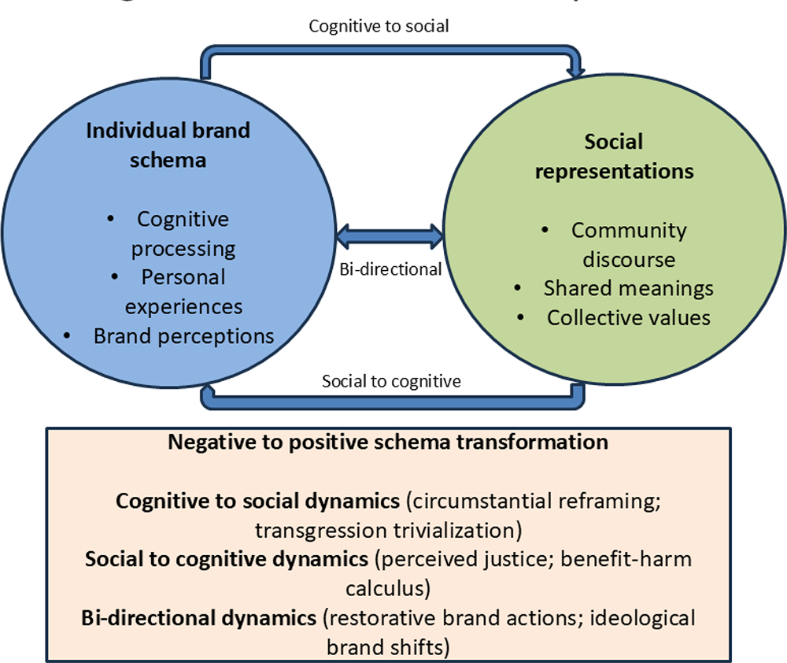
Figure 1: Theory of Schema Congruity and Brand Alliance Evaluation (Khan et al., 2025)

2.0.2 Brand Memory Models in the Associative Network
These models conceptualise brand knowledge as networks of interconnected associations stored in long-term memory, with brand alliances creating new pathways between previously separate associative networks (Keller, 2020). These connections define the ability of consumers to assess alliance fit and make purchase intentions based on their strength and nature (Bigné, Andreu, Perez, and Ruiz, 2020). Effective brand associations foster synergetic associations that can boost brand memory networks. Alliance partners with complementary associations create a more robust and accessible network, thus making brand recall and consumer evaluation more favourable. On the other hand, inconsistent associations about the networking nurtured in alliances may induce cognitive dissonance that leaks alliance efficiency and may destroy the brand value of an individual (Batra, Ahuvia, and Bagozzi, 2012).
Of recent literature, temporal dynamics of associative network formation have been especially addressed, where the strength of association was found to be established over time by repeated exposure and through positive consumer experiences. This result has significant implications for brand alliance management in that the benefits of the alliance might not be realised short-term but over time as consumers interact with the alliance. Also, it has been found that associated network processing varies between individuals, with highly engaged consumers showing a more detailed and mature structure of the network than less engaged ones (Khan et al., 2025).

2.0.3 Brand Alliance Acceptance and Self-Congruity Theory
The Self-Congruity Theory has become eminent in depicting consumer behaviour in line with brand alliances, especially in industries where brands involve vehicles of self-expression and self-identity development (Ashrafuzzaman, Parveen, Sumiya, and Rahman, 2025). According to the theory, self-congruity is important in brand alliance evaluation and recent studies have shown that there are various dimensions of self-congruity affecting brand alliance evaluation (Malr et al., 2022). Actual self-congruity provides the correspondence between brand image and consumers perceptions of their current identity, and ideal-self congruity has the correspondence between brand image and their aspirational identity goals.
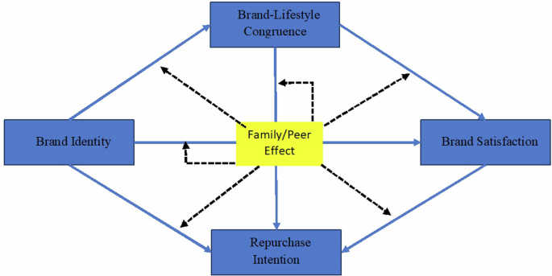
Figure 2:Brand Alliance Acceptance and Self-Congruity Theory (Khan et al., 2025)

2.1 Brand Alliance Contextual Consumer Behaviour

2.1.1 Brand Fit Perception and Buyer Evaluation Procedures
The experiences of consumer perceptions towards brand fit is the subject matter that has gained notable research in recent years with researchers having observed dimensions that influence the tendency of alliance evaluation. However, brand image fit has been found to be a somewhat more critical determinant of alliance success compared to product category fit and brand equity therefore indicating that symbolic compatibility usually supersedes functional similarity in the judgment of consumers (Paydas Turan, 2021). The fact that the study replicated the brand fit construct in different product-category boundaries and consumer segment variations makes it highly generalisable (Aggarwal, and McGill, 2012). More recent meta-analytic data have shed more light upon the relative values of various dimensions of fit, with relationship quality between partner brands being revealed as a crucial success factor. Studies have found that prior alliance connections among alliance members that occur due to similar target markets, complementary positioning or prior history of working together add considerably to consumer notions of fit (Delgado, et al., 2014).

2.1.2 Consumer Personality and Alliance Assessment
Brand involvement, defined as consumers' personal relevance and interest in specific product categories, has been shown to influence both the depth and nature of alliance evaluation (Das, Datta, and Guin, 2012). High-involvement consumers are likely to perform more comprehensive alliances evaluation, incorporate several fit dimensions and consequences, low-involvement consumers are more prone to use simple heuristics and shallow compatibility judgments (Cornelissen, 2017).

2.1.3 Hazard Perception and Union Assessment
The issue of consumer perceptions of risk with brand alliances has gained popularity in the recent literature, and researchers have isolated several dimensions of risk that can vary the evaluation of alliances. Functional risk is related to worries regarding product performance and quality and symbolic risk is related to possible damages to self-image and social status. According to recent studies, the functional risks are strongly attributed to alliance type where co-branded products possess significant risk concerns relative to marketing-only alliances (Chowdhury, Murshed, and Messier, 2024).

2.2 Company-Specific Insights: UK Liquor Market

2.2.1 Modern Trends in UK Liquor Industry Partnerships
The UK alcoholic drinks market generated a revenue of USD 115,402.8 million in 2023 and is expected to reach USD 248,238.1 million by 2030 (Chhabra, Shiriskar, and Srinivasan, 2025). The UK market is expected to grow at a CAGR of 11.6% from 2024 to 2030. In the last few years, the UK liquor sector has gone through profound change, where collaborations between brands have become more advanced and strategically relevant. Alcohol brands continue their sports partnerships reflecting the industry's recognition of experiential marketing's effectiveness in building consumer connections (Mintel, 2025).
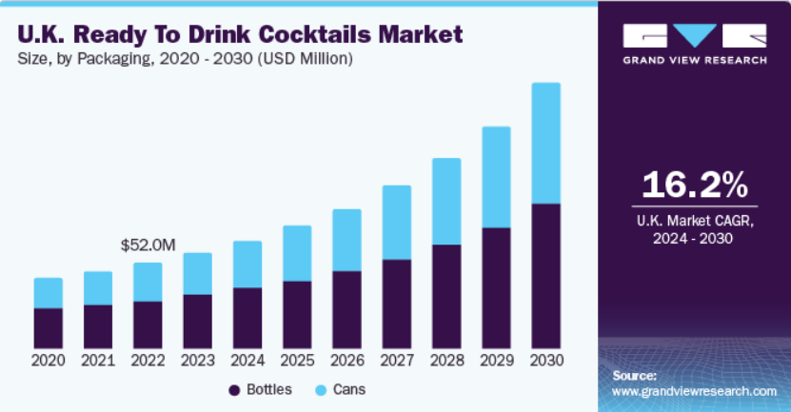
Figure 3:UK Liquor Market (Grand view research)
Recent industry analysis has identified several key trends shaping partnership strategies in the UK liquor sector. Collaborations with cultural icons, cross-brand partnerships, and limited-edition flavours keep vodka at the top of younger audiences' minds, demonstrating the industry's focus on maintaining relevance with evolving consumer preferences (OhBev, 2025). These trends reflect broader shifts in consumer behaviour, with younger demographics seeking authentic brand experiences and unique products that enable self-expression (Chernev, Hamilton, and Gal, 2011).

2.2.2 UK Liquor Consumer Behaviour
Consumer behaviour in the UK liquor market has demonstrated significant evolution over the past five years, with implications for brand alliance effectiveness. 72% of UK consumers reveal that sustainability practices influence their choice of bar or pub, with 58% willing to pay a premium for drinks served in venues with strong sustainability credentials (Continuous, 2025). This environmental responsibility-aware consumption has opened avenues to brand alliances concerned with environmental responsibility and ethical production
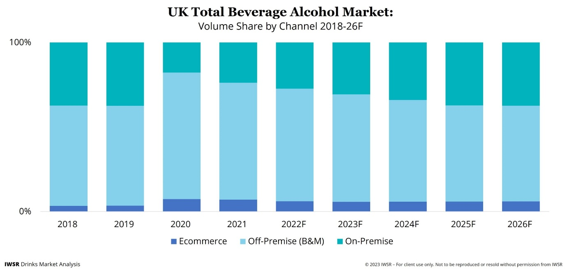
Figure 4: UK Liquor Consumer Behaviour
The age set represented among liquor consumers in UK has also dictated strategy of alliances within the strategic process given the varying preferences and evaluation variables adopted by the various age groups.

2.3: Formation of consumer attitude and purchasing intentions

2.3.1 Processes of Attitude Formation in Brand Alliance Situations
The literature on the development of consumer attitudes in reaction to brand alliances has covered vast research ground, and new studies are in the arena, reflecting very complicated mechanisms that incorporate both cognitive, affective and behavioural interferences (Chang, 2013). Cognitive processing includes consumer judgment of alliance fit, benefit analysis and risk, and an affective reaction includes emotional reactions to partners and configurations of alliances. Interaction between these elements’ conditions the overall formation of an attitude and its following purchase intentions.

2.3.2 Behavioural consequences and the formation of purchase intention
The formation of purchase intentions through brand alliance contexts has been found to be influenced by more factors other than attitude valence, and research has established important mediating and moderating variables that flash between attitude and intention. The translation of positive alliance attitudes to purchasing intentions is moderated by consumer involvement, brand relationship strength, and situational factors, all of which cast doubt on the sole reliance on measuring attitudes to predict alliance success.

2.4 Research Gaps

2.4.1 Gaps Specific to the Industry
Despite the abundance of literature on brand alliance success, there are still considerable gaps, in terms of industry-specific factors that can influence consumer evaluation procedures. The distinct features of the liquor business and the regulatory restrictions, as well as cultural importance and symbolical consumption of the product are rare topics in the current research on alliances. This gap presents a huge opportunity to develop theory and to promote practice regarding alliances principles.
Another missing item in the literature is the UK context of the marketing, with the studies having concentrated on the US or the European market in general. The specific conditions that may have a characteristic ability to define the effectiveness of the alliance that is not captured in the literature are the unique cultural background, the regulatory framework and consumer behaviour patterns in the UK. They are market factors that one must be familiar with the effective alliance strategies in the UK liquor industry.

2.4.2 Future Research Suggestions and Methodology Limits
The quantitative research that has occupied the research frontier on brand alliance efficacy has been burdened with the complexity of providing useful information about the general tendencies but is most likely to miss the finer and circumstantial details that go to play in the assessment that the consumers will make on the product. There is a gap in that there is no even usage of qualitative research methods concentrated on the specific contextual elements of the consumer alliance assessment that can provide the opportunity to create a more comprehensive understanding of the performance of the alliance.
Alliance assessment has also failed to capture longitudinal aspects, and most of the literature has cross-sectional designs to capture consumer responses at a given point in time. Consumer perceptions and practices longitudinal would be an added value to the understanding of how the effectiveness of an alliance would tend to fluctuate over time and what could be linked to long term success.

Chapter 3

3.0 Research Aim
The objective of the study is to learn more about the main consumer behaviour drivers that influence the level at which consumers evaluate the compatibility of liquor in brand alliances and the level at which they develop attitudes and make decisions to buy in the UK market.

3.1 Primary Objectives
- To provide a conceptual elaboration of the proper brand fit that is specific to the UK liquor situation in the eyes of the consumer.
- To determine the influence of the personal consumer traits (e.g. involvement, consumption patterns, brand loyalty) on their interpretations and judgments of liquor brand alliances.
- To provide rich and relevant information that can inform liquor companies on partnering and make decisions regarding their participation in the UK.

3.2 Secondary Objectives
- To develop detailed conceptual descriptions of "good" and "bad" brand fit specific to the UK liquor context from the consumer perspective.
- To explore how individual consumer characteristics (e.g. involvement, consumption patterns, brand loyalty) shape their interpretations and evaluations of liquor brand alliances.
- To produce information that is rich and relevant so it can guide liquor companies in selecting partners and making decisions about their role in the UK.

3.3 Conceptual Framework
A combination of well-known theories on consumer behaviour and brand management was applied to form the conceptual framework of the study, which draws on schema congruity theory and associative network models of brand memory (Cornelissen, 2017). The three theoretical underpinnings guided how the consumer perceptions of brand alliances in the UK liquor industry were analysed and interpreted. The framework itself combined various theoretical angles in order to reflect the complexity of consumer analysis processes when confronted with brand alliances.

Chapter 4: Research Methodology

4.0 Method of Research
The research adopts qualitative method of conducting research on the success of brand alliances in the British liquor industry with special consideration given to how the people of Britain perceive brand fit in a brand alliance as well as how they will buy brand alliance products. This method has been chosen because of its ability to capture subjective and non-linear nature of experiences and attitudes that makes up consumer decision-making processes of the context of brand alliances (Creswell, 2018). Qualitative paradigm enabled the study of psychological thinking that could not be evaluated in any numerical format but using high knowledge of thinking, like brand fit perceptions.
The nature of this study is such that the researchers set out to apply an interpretivist philosophy to the research where the social construction of perceptions about brand alliances are relative in their contexts. This way of positioning allowed us to investigate how personal and cultural contexts of individuals create a sense of brand partnerships. The study followed a research design that included the principles of the grounded theory, allowing the researchers to unveil theoretical insights within the data themselves instead of applying existing frameworks.

4.1 Research Design
The phenomenological qualitative design was used to achieve the lived experience of consumers that encounter brand alliances in the UK liquor market. This design choice was informed by the need to have a better understanding of subjective meanings that consumers had placed on the idea of brand partnerships and the degree to which those meanings had influenced their intended purchase. The current research design was cross-sectional in nature, meaning that within the study, the data were only measured at a single point to give a small picture of the prevailing attitudes of consumers to brand alliances in the liquor industry.
In order to triangulate results and maximise validity of the findings, both consumer and expert assessments were employed in the study. The two-way analytical structure ensured that the effectiveness of brand alliance could be discussed through the lenses of different stakeholders, which provided a wide perspective of the phenomenon under consideration.

4.2 Sampling and Population Strategy

4.2.1 Target Population
The two target groups consisted of the 18 and above consumers in the UK who had prior experience with alcoholic drinks and the industry specialists with professional interest on UK liquor markets. To ensure that the respondents were relevant and experience was fresh, the consumer respondents were also reduced to those who recalled having experimented brand alliances in the liquor business within the last 12 months.

4.2.2 Method of Sampling
The study employed a purposive sampling method in choosing the study participants that would provide rich and relevant data to meet the objectives of the research (Cornelissen, 2017). The consumer participants were formed using the criterion sampling method in which the set inclusion criteria was developed such that the participants should hold the necessary knowledge and experience that they will make significant contributions to the study. The criteria included age 18 or above, regular consumption of alcoholic beverages (at least once per month), awareness of brand alliances in the liquor industry, and residence in the UK for a minimum of two years.
In the case of the expert participants, expert sampling was used to select the individuals with specific expertise about brand alliances and the UK liquor market. The selection criteria were as follows: at least five years of work experience within the liquor industry, first-hand marketing or alliance experience with liquor brands, or present or recently worked directly in the UK with liquor companies, marketing agencies, or distribution organisations.

4.2.3 Calculation of Sample Size
The sample size was calculated upon the data saturation principle, which is one of the main concerns of qualitative research. The purpose of the study was to apply theoretical saturation when no new themes and insight can be derived out of additional interviews. Based on the established tenets of the work on the qualitative research and by analysing the phenomenon of consumer behaviour, the research disposed of about 10-12 consumer-led interviews and 3-5 expert-led interviews.
It was considered that the time spent on sampling was adequate to achieve data saturation and at the same time ensuring the richness of the analysis which is characteristic of a qualitative study. The sample size of the consumers was congruent with phenomenological research guidelines, which suggests 10-15 individuals to study the scope of the given phenomenon (Creswell, 2018).

4.3 Methods of Collecting Data

4.3.1 Semi-Structured Interviews
The primary method of data collection was semi-structured interview, which allowed giving the chance to follow emergent themes and be in danger of being led to far in the data and having the possibility of being too off topic in relation to central research questions (Cornelissen, 2017). This strategy made it possible to report in details on what considerable number of consumers go through in accordance to the brand alliances and views of experts about the industry practices.
A topic guide was used to interview consumers, which included briefings on brand alliance awareness, brand fitness concerns, deciding to buy factors, and emotional reactions to the brand alliances. Two consumers were used to pilot the interview guide to make sure that the questions were clear and appropriate. The interviews with consumers took about 45-60 minutes to ensure that there was enough time to explore the experiences and perceptions in-depth.
Interviews with experts involved a different topic guide leading in the area of industry view of brand alliance strategy, success factors, consumer behaviour insights and market trends. Interviews with experts were generally longer (60-90min) to allow space to cover the professional knowledge and experience they were discussing.

4.4 Data analysis approach
The study employed grounded theory methodology for data analysis, specifically following the systematic approach outlined by Strauss and Corbin (1998). This approach was deemed appropriate because it helps to develop a theory based on empirical findings, making it especially appropriate to study the relatively unexamined field of perception of brand alliances in the liquor industry.
Such an emphasis on patterns and connections in the data proved viable using the grounded theory method of analysis, where connections that may not have clearly appeared using a different method were identified. It was an inductive method where theoretical considerations arose out of primer outcomes other than how they were imposed by pre-existing frameworks.

4.4.1 Three-Stage Process of Coding
The collected data were analysed in a multistage coding process typical of the grounded theory approach:

Open Coding
The first phase of data analysis was open coding, which involved analysing transcripts line-by-line to determine individual concepts and phenomena. This process involved breaking down the data into meaningful units and assigning initial codes that captured the essence of participants' experiences and perspectives.

Coding Stage | Purpose | Process | Output
Open Coding | Identify initial concepts and categories | Line-by-line analysis of transcripts | Initial codes and concepts
Axial Coding | Establish relationships between categories | Systematic analysis of category connections | Core categories and subcategories
Selective Coding | Develop central theory | Integration around core category | Theoretical framework
Table 1: coding summary
Throughout the process of open coding, the research kept a record of coding memos diligently to note analytical choices and findings. The memos acted as an audit trail and were helpful during the creation of analytical thoughts during the coding process.

Axial Coding
Axial coding entailed careful analysis of how categories discovered under open coding related to each other. During this step, attention was paid to issues of determining conditions, contexts, and consequences that influenced the phenomena under study. The analysis revealed the ways in which various categories were connected to one another and started building a more consistent understanding of the data.
Category | Properties | Dimensions | Related Categories
Brand Fit Perception | Compatibility, Coherence, Authenticity | High-Low, Natural-Forced | Purchase Intention, Trust, Brand Image
Consumer Scepticism | Doubt, Questioning, Resistance | Mild-Severe, Temporary-Persistent | Brand Credibility, Previous Experience
Value Perception | Benefit Recognition, Worth Assessment | Functional-Emotional, Individual-Social | Purchase Decision, Satisfaction

Selective Coding
The last phase of analysis was selective coding during which the core category was recognized and combined with other categories to form a consistent theoretical foundation. At this phase, there was development of a smoother theoretical model with clear association among key categories established.
Selective coding process led to creation of a central story line explaining how brand fit consumer perceptions determines purchase intentions in the context of brand alliance in the UK liquor industry.

4.5 Details of Data Collection Timeline and Procedures

4.5.1 Response Timeline
The data collection process took place in eight weeks (June to August 2025). The interviews with consumers were followed by interviews with experts to enable questions based on consumer perspective to be posed to experts. This sequenced process provided a richer form of expert interviews because it allowed the engagement of actual consumer insights with industry experts.

4.5.2 Recruitment of Participants
Participants were consumer-based and were recruited as a combination of social media adverts, university networks, and snowball sampling. The preliminary recruitment criteria were based on achieving a diverse sample regarding age, sex, and purchase behaviour to obtain a wide range of views. Professional networks, industry associations and contact with relevant organisations were used to recruit expert participants.
Informed consent was obtained by all participants prior to their participation, and ethical approval of the study was awarded by the university ethics committee before data were collected. The respondents were provided with a chance to have their interview transcripts read to them and make comments on the correctness of transcription.

4.6 Implementation of the Analytical Framework

4.6.1 The Structure and Categories of Coding
The implementation of the analytical framework was systematic to provide rigour and transparency of the analysis process. The table 2 below shows how the categories of coding develop during the three-stage process:
Open Codes | Axial Categories | Selective Themes
Product quality concerns, Price sensitivity, Brand reputation | Consumer Decision Factors | Purchase Intention Formation
Logical fit, Emotional connection, Brand values alignment | Brand Fit Dimensions | Brand Compatibility Perception
Marketing manipulation, Authentic partnership, Commercial motives | Alliance Credibility Assessment | Trust and Authenticity Evaluation
Social acceptance, Personal image, Group belonging | Social Influence Factors | Identity and Social Consideration
Table 2:Categories of Coding

4.6.2 Saturation of Theories
The collection and analysis of new data was stopped once a theoretical saturation when there were no new properties, dimensions, or relationships observed was obtained. This was done following the completion of ten consumer interviews and four expert interviews, which shows that the sample was relevant to the research objectives. The last round of interview transcripts validated previously existing categories and relationships and did not require new theoretical elements to be introduced.

4.7 Measures of Quality Assurance and Validity

4.7.1 Criteria of Trustworthiness
The data was housed in secure systems in password-protected digital files. The anonymity of participants was upheld by applying pseudonyms and by having identifying features of transcripts deleted.

4.8 Ethics

4.8.1 Consent and Ethical Approval
Data were collected with the approval of the university research ethics committee. Each of the participants was provided with information sheets containing specific details of the research purpose, process and their rights as a research participant. Every participant was asked to sign written informed consent, and special permission was received to record audio recordings of interviews.

4.8.2 Rights and Welfare Participants
The subjects were told that they could drop out of the study without any repercussions. The study design involved the use of steps aimed at reducing the risk of psychological discomfort, and the subject of the brand alliance was deemed to be of low risk. The participants received contact information for support services in case their participation caused any problems.

4.8.3 Confidentiality and Data Protection
Participants' identities were protected through anonymisation procedures, and all data was stored in compliance with university data protection policies. After transcription and verification, audio recordings were destroyed, and only anonymised transcripts were left to be analysed.

4.9 Restrictions and Methodological Discussions

4.9.1 Limitations of the Sample
The study's focus on UK consumers limited the generalisability of findings to other national contexts where consumer behaviour and cultural factors might differ. The sample size, while appropriate for qualitative research, restricted the ability to make broad generalisations about consumer behaviour across diverse demographic segments.

4.9.2 Methodological Limitations
The cross-sectional approach recorded the perceptions of consumers at only one point in time and was susceptible to evolutionary changes in the mind-set of the brand alliance. The social desirability bias could be a problem because the data was self-reported; however, the qualitative strategy allowed the researchers to extract sincere answers and determine the possible inconsistencies.

Chapter 5: Results

5.0 Introduction
The chapter presents the results and discussion of a qualitative analysis of consumer and expert interviews regarding the study of brand alliances within the UK liquor industry. The key aim of this chapter is to define the key themes that have been found during the interviews and to state on them as they relate to the brand partnerships in this industry. The data was coded with the help of open coding, axial coding and selective coding, and allowed finding central themes connected with the topics of consumer engagement, brand perceptions, success factors of partnerships, and risks (Deloitte, 2020; Keller & Swaminathan, 2020).
Table 3 below contains a summary of the demographic characteristics of this study participants who were interviewed to the study. It contains their gender and the age, which were used in explaining the variation of the responses among the different demography groups.
Participant Number | Gender | Age
Consumer 1 | Female | 31
Consumer 2 | Male | 28
Consumer 3 | Female | 25
Consumer 4 | Female | 38
Consumer 5 | Male | 28
Consumer 6 | Male | 38
Consumer 7 | Female | 23
Consumer 8 | Female | 37
Consumer 9 | Female | 33
Consumer 10 | Female | 20
Expert 1 | Male | 35
Expert 2 | Female | 43
Expert 3 | Male | 37
Expert 4 | Female | 30
Table 3:Demographics of Participants in Sample
For consumers, themes such as product preferences, brand loyalty, and perception of authenticity were particularly prominent, while experts focused more on strategic alignment, partnership risks, and brand fit (Tymon & Stumpf, 2021). These themes will be touched on in this chapter comparing and contrasting the two views.

5.1 Process of Analysing Data

5.1.1 Open Coding
During the process of data collection, 14 interviewees, which consisted of 10 consumers and 4 professionals, were asked about their preferences and opinions on the matter of brand partnerships in the liquor market. As can be seen in Table 1, participants were different in age and belonging to different genders, which provided a possibility to have varied opinions about the matter. Transcription of interviews was done verbatim and analysis commenced at the open coding stage Inductive approach was adopted in the process of coding i.e. the codes were not predetermined but were actually developed out of the interview transcripts. This process involved a detailed examination of the data to uncover recurring patterns and concepts, which were then labelled accordingly (Strauss & Corbin, 1990). The data in each significant part of the text were assigned distinctive code names to classify the information and these codes were recorded in a code book. The code book was also provided with short descriptions of each code and the place where the code could be found in the interview transcript so that the meaning of the codes was the same throughout the analysis process.
In this stage, codes were used to highlight specific topics discussed by the participants, such as "Brand Loyalty", "Taste Preference", and "Sustainability". The aim was to sort out similar themes and concepts arising out of data. For example, consumers who showed strong preferences for specific brands were grouped under the "Brand Loyalty" code, while those mentioning environmental concerns were grouped under "Sustainability".

5.1.2 Axial Coding
After the open coding was done, the next step was the axial coding where we aimed at spotting patterns and associations between the original codes. In axial coding, we combined related open codes into wider groups of codes or axial codes. This step was done to elaborate and distinguish the themes by examining their associations and orders (Charmaz, 2006). To illustrate, the codes of Brand Loyalty, Brand Trust, and Brand Identity were merged into the axial code of Consumer Brand Engagement that implies the emotional and cognitive associations between consumers and brands.
Likewise, the codes dealing with consumer desires, including, taste preference and product variety were subsumed under axial code of product preferences. The raw data were actually made clear with the help of axial coding, and it also offered a structure in terms of comprehending various dimensions of brand interactions.

5.1.3 Selective Coding
The last phase of the coding process was selective coding that entailed a synthesis of the axial codes into general themes or core categories that would be able to explain how the different factors that affect consumer behaviour relate to one another. This was intended to arrive at a central and unifying theory that would be able to explain the most important results of the data (Strauss & Corbin, 1990).
As an illustration, the axial codes such as, Brand Loyalty, Brand Trust, and Brand Perception were narrowed down to selective code (Consumer Brand Engagement) that become a core theme. The theme summarized how consumer-brand interaction was affected by aspects of trust, emotional connection and brand identity.

5.2 Consumer involvement with brand
Brand engagement is one of the most crucial concepts related to the process of consumer interaction with brand unions.
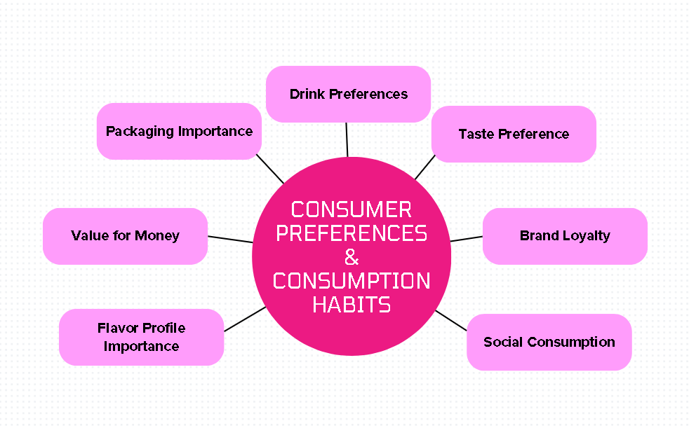
Figure 5:Axial Coding- Consumer Preferences & Consumption Habits
The consumer considerations have been viewed like this; the consumers have some concern about brand engagements depending on consumer preferences, product consumption, attempt to build their conception about the brand and the manner in which it forms their responses towards brand affiliations. Consumer engagement with brand alliances is shaped by emotional connections, brand loyalty, and perceptions of authenticity (Keller and Swaminathan, 2020).

5.2.1 Tastes and patterns of consumption
One of the themes that emerged during the interviews in perception of brand alliances is the preference of the consumers. The consumers were firm with their inclination in regard to consuming some types of alcoholic beverages such as gin, rum, and whiskey, and had direct effects on influencing the perception of consumers about brand partnership. To exemplify, majority of the consumers asserted that their preferred drink types were among determinants of whether the consumers were willing to cooperate with brands or not. For example, one participant mentioned, "I always choose gin when going out with friends, and if my favourite gin brand partnered with a new mixer I liked, I’d definitely give it a try" (Consumer 3).
Social consumption was another factor that dictated how the consumers responded to brand partnerships. According to many respondents, they usually determine what to drink depending on the social setting. For example, a respondent noted, "When I’m out with friends, I choose something that fits the occasion, so if a high-end gin brand collaborated with a premium event, I’d be more inclined to buy it" (Consumer 7).

5.2.2 Brand Perception of the Consumer
Another strong theme of consumer response was brand perception. The importance of brand loyalty and trust came up as the key to the perception of brand alliances by the consumers. Most of the respondents indicated that this loyalty to a certain brand played a major role in determining their perception towards a partnership of that brand. For example, a participant shared, "I’m loyal to Hendrick’s gin, so if they partner with another premium brand, I’d trust it would be a good match" (Consumer 1).
Besides brand loyalty, consumers underlined authenticity in brand alliance. The brands that partnered had a common and clear identity, and thus they were perceived to be authentic. As one interviewee stated, "I think a gin brand working with a local farm for fresh ingredients feels authentic, but a gin brand partnering with a tech company feels off" (Consumer 5). This displays the fact that genuineness in relationships is essential in ensuring brand trust and consumer interaction (Cao, Raab, and Bergman, 2025). The consumers will tend to accept the collaborations that seem authentic and match the values of the brand.

5.3 Success Factors of Partnership
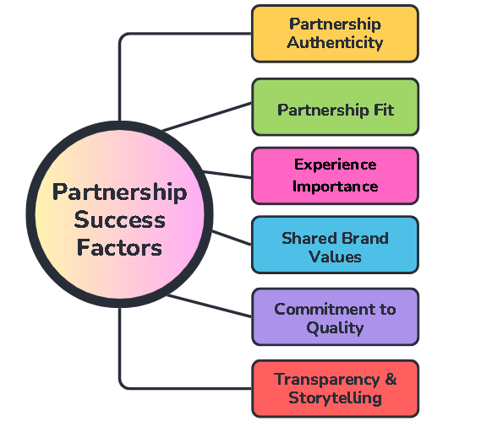
Figure 6: Axial Coding- Partnership Success Factors

5.3.1 Brand Fit
The issue of brand fit became one of the dominant themes in the consumer and expert interviews. Brand fit is understood as the match of two brands in terms of target audience, values, and product (Cornelissen, 2017). Consumers were especially sensitive to the extent that two brands fit together in a partnership, and the reaction of the consumer was frequently conditioned on its naturalness. For instance, a participant remarked, "I can see a gin brand collaborating with a cocktail mixer, but a gin brand teaming up with a tech company just doesn’t make sense to me" (Consumer 4). This shows that perceived compatibility plays a significant role in consumer decision making, which has a direct influence on their desire to assist in a brand alliance.
Experts also emphasized the importance of brand fit in ensuring that a partnership aligns with both brands' strategic goals and target audience. As one expert noted, "A good partnership happens when both brands have a similar target demographic and share values that resonate with their consumers" (Expert 2). This alignment helps to reinforce the authenticity of the partnership and enhances its likelihood of success. According to Tymon and Stumpf (2021), strategic fit in brand alliances is essential for fostering consumer trust and loyalty, as mismatched partnerships can lead to confusion and diminish brand equity.

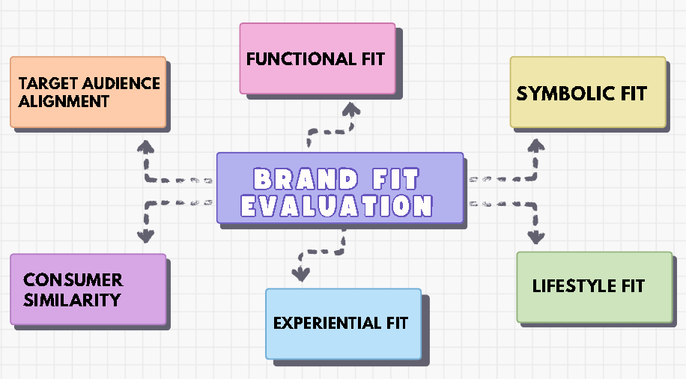
Figure 7:Axial Coding- Brand Fit Evaluation

5.3.2 Risk Management
Although brand fit plays an important role in determining the success of brand alliances, management of partnership risks is also important. Risk management emerged as another important factor that determined the life span and success of brand partnerships both among the consumers and the experts. Consumers raised issues on the risks that might exist due to brand misalignment such as quality or authenticity dilution. As one participant stated, "If a luxury brand partnered with a cheap product, I’d question the quality of both" (Consumer 8). This is an echo of the typical consumer concern that partnerships can lead to the erosion of brand value in case of not selecting the brands involved with special care.

5.3 Consumer Preferences and Brand Trust
Consumer preferences and brand trust are important in influencing consumer behaviour in terms of brand alliances. As a result of the interviews, it was evident that the preferences of different consumers to certain kinds of products and brand loyalty plays an important role in the perception of the consumers towards brand partnerships. Also, brand trust which has been created over a period due to positive consumer experiences is important in creating the willingness to take part in a brand collaboration.

5.3.1 Preference to Product and Brand Loyalty
One of the major themes that came out of the interviews was the connection between brand loyalty to product preferences. The more attached a consumer is to a certain brand, the more likely he or she is to embrace partnerships involving such a brand. For example, one consumer mentioned, "I’ve been loyal to Hendrick’s gin for years, so if they teamed up with a trusted mixer, I’d definitely try it." This was the feeling that was echoed in most interviews, brand loyalty was a parameter of protection. The consumers were more sure of their choice to buy a product of a brand that they knew and when it was collaboration with a brand they trusted.
Brand loyalty does not only reveal the emotive attachment of a consumer towards a product but also determines the receptiveness to partnerships. The more loyal the consumers are, the more they can perceive partnerships as an extension of their relationship with the brand, establishing a feeling of reassurance. One participant explained, "I always buy Macallan whiskey, so if they partnered with a premium food brand, I would trust that it’s a quality collaboration." It highlights the fact that loyal customers regard brand alliances as an opening to experiment with new products in the safe environment of a known brand.

5.3.2 Values and preferences

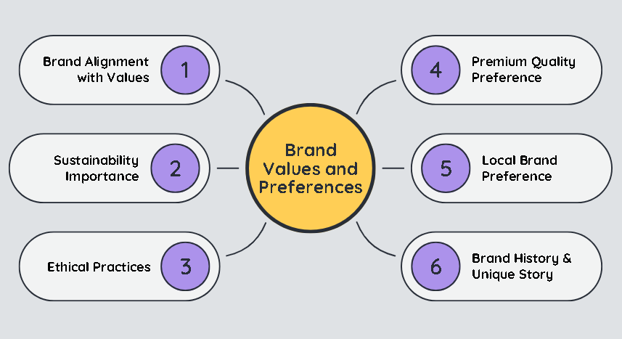
Figure 8: Axial Coding- Brand Values and Preferences
The other important theme was the relevance of brand values in influencing brand alliances in the mind of consumers. The consumers do not only worry about the functional advantages of the products but also worry about the values that the brand conveys. For example, one respondent shared, "I care a lot about sustainability, so if my favourite gin brand teams up with an eco-friendly packaging company, I’m all for it." This is a sign of the recent trend in values-based consumption, where people identify themselves with the brands that have the same ethical or social values as they have.
The importance of the brand values in the brand alliances was particularly evident when speaking about the authentic partnerships. In case of two brands with similar values, e.g., concern with the quality of the product or environment-friendliness, the consumers are likely to be more accepting of the collaboration. One interviewee explained, "If my favourite whiskey brand collaborated with a local organic farm, I’d support that for sure." This explains that consumer trust and engagement can be achieved when the brands embrace the values that people are passionate about.

5.4 Perception and Building of Brand Loyalty

Brand loyalty is one concept that matters a lot in consumer involvement particularly in the brand alliance scenario. The section addresses how brand alliances could be used to develop brand loyalty and brand perception development. The valuable relationships with consumers would most likely see them connect with a brand more and enhance their experiences, especially in the context of fulfilling their expectations. What is more, brand alliances can define the attitude of the consumers to the brand development process, either supporting its image or creating problems with the trust building.
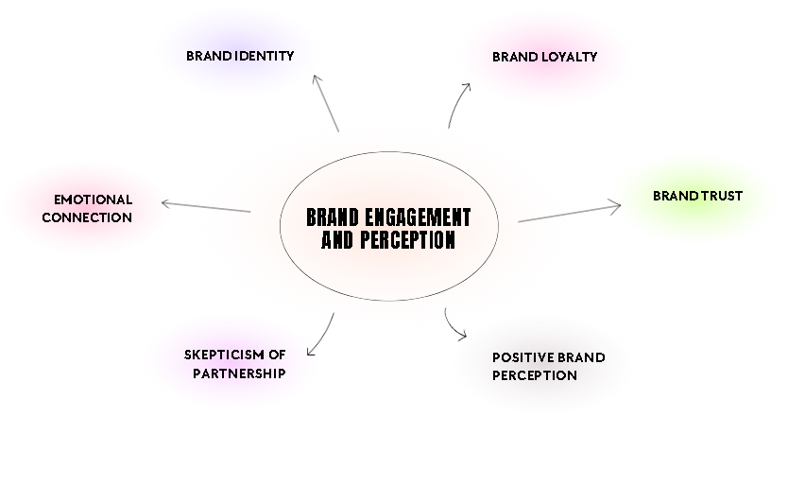
Figure 9:Axial Coding- Brand Engagement and Perception

5.4.1 Developing Brand Loyalty
One of the main findings that were discovered through the consumer interviews was that brand alliances are of great importance in creating brand loyalty by exposing loyal customers to new experiences, products or services that allow them to identify with the brand. For instance, one participant explained, "I’ve been loyal to Bombay Sapphire for years, and when they launched a special edition with a unique flavour, I immediately bought it. It made me feel more connected to the brand" (Consumer 2). This shows that co-branding with exclusive products or experiences can enhance the emotional attachment a consumer has towards a brand.

5.4.2 Brand Evolution Perception
Although brand loyalty has played an important role in consumer behaviour, brand evolution is also determined by how customers view changes or innovations that have been initiated by the collaboration of brands. Brand alliances have the potential to either enhance or challenge a brand's image depending on how well the collaboration aligns with consumer expectations.
Some consumers viewed brand partnerships as a natural progression in a brand's evolution. For example, one respondent explained, "When my favourite gin brand started partnering with local artisans for limited edition flavours, I saw it as a brand evolving in a more creative and innovative direction" (Consumer 5). This is indicative of the fact that partnerships that are consistent with the value system of a brand and the product/service offerings of the latter are regarded as a good brand development. In such events, the consumers believe that the brand is changing and growing but with the level of quality and authenticity that they cherish.

5.5 The Risk of Partnership and Consumer Concerns
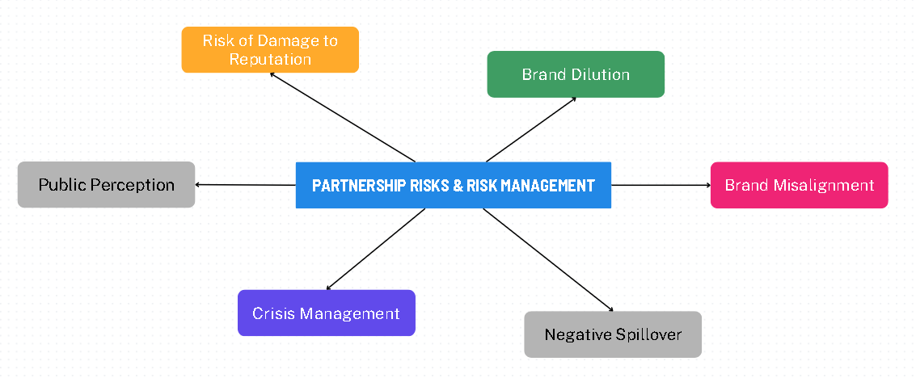
Figure 10: Axial Coding- Partnership Risks and Risk Management

5.5.1 Brand Misalignment
Partnership of brands may be a lot of advantages, yet it is accompanied by a lot of risks, especially brand misalignment. In case two brands are working together, it is important that they are on the same side in regards to values, targeting and products. Misalignment between brands can confuse consumers, potentially damaging both brands' reputations.
A considerable number of consumers stated that they tend to disapprove a partnership when they see a conflict between the brands. As one participant explained, "I can’t understand why a whiskey brand would partner with a tech company. It just doesn’t make sense to me" (Consumer 6). This was reiterated by some other participants and the strategic alignment is one of the key success factors in effective brand partnerships.

5.5.2 Brand Collaboration Anxieties of Consumers
Other than brand misalignment, the consumers also raised their concerns regarding the reasons behind brand collaborations. The first is that there is a likelihood that the brands are taking advantage of consumer loyalty with a view of accruing financial benefits, yet they are not giving anything tangible to the consumer. A participant explained, "I don’t want to feel like a brand is just trying to make money off my loyalty. I want collaborations to offer something new or meaningful" (Consumer 8). This issue indicates the rising value of openness and authenticity in brand associations. Consumers would connect more with those partnerships which do not seem to be driven by profits only.
There was another major issue which was the risk of consumer confusion. One of the participants said that brand alliances are other times so complicated or twisted that the consumers cannot tell what the collaboration was about or the benefit of the relationship. As one interviewee stated, "If a fashion brand and a vodka company collaborate without a clear connection between the products, I don’t see the point" (Consumer 10). The resulting confusion may encourage consumer distrust that the collaboration is more of a marketing exercise than offering something meaningful to the consumer.

5.6 Chapter Summary
The consumer and expert interviews data analysis gave significant data about the factors that affect brand alliances especially in the UK liquor industry. Among the most important findings is that consumer preferences and brand loyalty are the strongest factors that determine the way consumers react to brand partnerships. Customers with high brand loyalty to particular brands will find themselves willing to become involved in collaborations that include brands that they prefer to patronize, as long as such partnerships fit their expectations, values and previous experience when dealing with the brand. The consumer response depended mainly on emotional connections since they prefer to have partnership with companies which feel natural and fit their personal values like sustainability, quality, and trust. As an example, people will tend to adopt more the partnerships that will demonstrate the values they place on a certain brand, which will also make them more loyal to that brand and the partnership activity. This underscores the importance of emotional bonding and value harmony in consumer attitude of brand partnerships.

Chapter 6: Discussions

6.0 Chapter overview
This chapter provide a discussion about the most important findings of the research as compared to the objectives of the study. It particularly covers the three main goals of the research which include; to investigate how consumers perceive brand alliances in the UK Liquor industry, to do an analysis of how brand alliances influence consumer behaviour and what are the important factors that influence consumer acceptance of brand alliances. This chapter critically examines the extent to which the findings answer these objectives and discusses the implications of these findings to the brand managers and marketers in the liquor industry by looking at the results of both the consumer and expert interviews.

6.1 Examine Consumer Perceptions of Brand Alliances in the UK Liquor Industry
Consumer perceptions have a critical role in determining the success of brand alliances, especially in such an industry as the UK liquor market where brands tend to have significant cultural implications and emotional attachment (Brignoli, 2022). The research shows that consumers are very sensitive to the genuineness of brand partnerships and are inclined to appreciate the partnerships which are consistent with their personal preferences and values. Specifically, it was found that when consumers consider the compatibility of the partnering brands to be authentic and complementary, they develop positive attitudes towards alliances (Halkias, and Kokkinaki, 2014). For instance, a gin brand collaborating with a premium mixer was considered a natural fit by most respondents, indicating that perceived brand compatibility plays a significant role in shaping consumer perceptions (Tymon & Stumpf, 2021).
Moreover, brand loyalty became the important determinant in consumer attitudes towards brand alliances. Loyal consumers to a given brand will be inclined to alliances that carry that brand, particularly the situation where the brand does not lose its essence (Gürhan-Canli, and Maheswaran, 2010). Nevertheless, even the slightest hints of a misalignment or partnerships that seemed not natural were received with scepticism. For example, some participants expressed concerns when a premium whiskey brand partnered with a mass-market company, fearing that the collaboration might dilute the brand's quality (Keller & Swaminathan, 2020). The results of the study emphasize that consumers are not mere receivers of brand collaborations, but are actively involved in the assessment of the authenticity and relevance of such cooperation (Guo, and Hsu, 2023).

6.2 Evaluate the Impact of Brand Alliances on Consumer Behaviour
Brand alliances play a significant role in influencing behaviours of consumers in an industry where consumers are used to brand loyalty and emotional attachments to brands and in the UK liquor market this is highly prevalent. The paper reveals that brand partnerships can greatly impact customer buying behaviour in the form of either increasing the perceived value of a product or bringing new experiences that consumers see in their identities. When a brand alliance is perceived to add value, it would attract the consumers to be more involved with such an alliance. For example, exclusive collaborations, such as limited-edition products, tend to trigger purchase intentions by creating a sense of scarcity and exclusivity (Deloitte, 2020).
In addition, the research establishes that brand alliances are able to support brand loyalty. People who are already emotionally attached to a brand are likely to accept and embrace its partnerships (Ge, et al., 2025). A participant who was loyal to a particular whiskey brand noted, "If my brand partners with someone I trust, I’ll definitely support it." This aligns with previous research that suggests that brand loyalty leads to higher consumer acceptance of brand alliances, as loyal customers view the partnership as a natural extension of their relationship with the brand (Keller & Swaminathan, 2020).

6.3 Identify the Key Factors Affecting Consumer Acceptance of Brand Alliances
The study establishes that there are some major determinants of consumer receipt of brand alliances in the UK liquor trade. The most important among these factors is the brand fit which is the perceived brand compatibility of the brands that are partnering (Fournier, and Alvarez, 2013). A brand alliance will be more likely to be accepted by the consumers when the brands involved appear to be a natural match, not only in the markets they target, but in what they value as well. For instance, partnerships between brands that share a commitment to quality, sustainability, or authenticity are generally viewed more favourably than those that appear to be driven by commercial motives alone (Tymon & Stumpf, 2021).
Perceived authenticity is another important aspect that determines consumer acceptance. Customers do not trust partnerships that are unnatural or are merely based on profitability (Fournier, and Alvarez, 2013). As an illustration, consumers complained that a premium brand partnered with a mass-market brand since such cooperation did not conform to the image of the brand. This perception of inauthenticity can result in negative attitudes toward the collaboration and may even damage the brand's reputation (Keller & Swaminathan, 2020).

Chapter 7: Conclusion

7.0 Conclusions
This research sought to examine consumer attitudes towards brand alliances in UK liquor industry especially the effects that brand alliances have on consumer behaviour and the determinants of consumer acceptance. The research met its main goals, and, with the help of qualitative evaluation of consumer and expertise interviews, provided the community with invaluable information about the world of marketing and brand management.
This research ascertained that brand fit, authenticity and emotional involvement with the brand are some of the factors, which determine brand alliance perceptions of the consumer (Eklund, and Helmefalk, 2022). Customers tend to favour the unions that fit their predispositions and ideals, especially when the synergy of the partnerships seems natural and applicable. Brand partnerships promoting unique products or experience or strengthening the brand to the consumer identity were also perceived as positive, and they enhanced brand loyalty and purchase intentions (Keller & Swaminathan, 2020).

This study had findings that were also central with respect to the impact that brand alliances would have on consumer behaviour. The implication of brand alliances to the purchasing process can be very deep since it provides the consumer not only with a sense of exclusiveness but also a sense of brand value. More importantly, consumer loyalties will be more effective in creating long-term consumer loyalty when consumer alliances are based on the value systems and emotional attachment (Tymon and Stumpf, 2021). However, alliances perceived as a company or not authentic enough were looked down upon cynically and could negatively affect the interaction with consumers (Keller and Swaminathan, 2020).
The study found the key determinants that were involved in consumer acceptance of brand alliances such as perceived compatibility of brands, authenticity and transparency. The consumers claimed to prefer partnerships that complement their interests and values, and partnerships that were considered to be unauthentic or those which are strategically incongruent were also more likely to be rejected (Deloitte, 2020). Having transparency about how and why a partnership happened, what benefits could be in it, and to assist create consumer acceptance were very important.

7.1 Limitations
While this study provides valuable insights into consumer perceptions and behavioural impacts of brand alliances in the UK liquor industry, it is not without its limitations. The scope of this research is primarily focused on the UK market, and thus, the findings may not be directly applicable to other regions with different cultural and regulatory contexts. The study's geographical focus limits the ability to generalize the results to international markets or emerging markets with distinct consumer behaviours (Bohara, Gupta, & Kumar, 2025).
The sample size despite the fact that 14 consumer interviews and 4 expert interviews were used in the study, a larger sample size would create better data and enable them to have a better understanding of the different consumer segments available in the UK liquor industry. For instance, a more diverse sample could account for the differences in age, gender, income, and cultural background, all of which may influence consumer perceptions of brand alliances (Bohara, Gupta, & Kumar, 2025).
The research also relies on qualitative methods (interviews) which, while rich in detail, are subject to subjectivity and interviewer bias. Although efforts were made to reduce these biases, personal interpretation and respondents' own biases might have influenced the data collection process (Molnár, Keszey, & Frau, 2024). Additionally, the study focuses on consumer perceptions and expert insights rather than actual commercial performance of brand alliances, limiting its ability to directly assess the financial impact or market success of partnerships (Thomas, Fowler, & Taheran, 2024).

7.2 Future Research
Due to the identified limitations, one can suggest some research directions to be addressed in the future to supplement the results of the current study and enhance the knowledge on brand alliances in the liquor industry.
Potential future research is to consider alternative markets beyond the UK including the emerging markets where the behaviour of consumers and what they expect in a brand may vary. Cross-cultural studies would provide valuable insights into how brand alliances are perceived in diverse cultural contexts and whether the factors influencing consumer perceptions vary across regions (Goi, Chieng, & Goi, 2023).

References
- Aaker, J.L., Fournier, S. and Brasel, S.A., 2010. When good brands do bad. Journal of Consumer Research, 31(1), pp.1-16.
- Aggarwal, P. and McGill, A.L., 2012. When brands seem human: Do consumers relate to brands as people? Journal of Consumer Psychology, 22(3), pp.312-325.
- Ahn, J., Shamim, A. and Park, J., 2021. Impacts of cruise industry corporate social responsibility reputation on customers’ loyalty: Mediating role of trust and authenticity. International Journal of Hospitality Management, 92, p.102680.
- Ashrafuzzaman, M., Parveen, R., Sumiya, M.A. and Rahman, A., 2025. AI-powered personalization in digital banking: A review of customer behaviour analytics and engagement. American Journal of Interdisciplinary Studies, 6(1), pp.40-71.
- Batra, R., Ahuvia, A. and Bagozzi, R.P., 2012. Brand love. Journal of Marketing, 76(2), pp.1-16.
- Beverland, M.B. and Farrelly, F.J., 2010. The quest for authenticity in consumption: Consumers’ purposive choice of authentic cues to shape experienced outcomes. Journal of Consumer Research, 36(5), pp.838-856.
- Bigné, E., Andreu, L., Perez, C. and Ruiz, C., 2020. Brand love is all around: A study on brand love and its effects on consumer behavior. European Journal of Marketing, 54(7), pp.1563-1588.
- Blackston, M. and Lebar, E., 2015. Building brand equity through authenticity: Engaging the new consumer. Journal of Brand Management, 22(5), pp.384-398.
- Bohara, S., Gupta, G. and Kumar, V., 2025. Integrating artificial intelligence and consumer behaviour: Insights and directions from a hybrid systematic literature review. Journal of Marketing Communications, pp.1-30.
- Brexendorf, T.O., Keller, K.L. and Lehmann, D.R., 2015. Brand crises: The roles of brand familiarity and crisis relevance in consumer evaluations. Journal of the Academy of Marketing Science, 43(5), pp.593-608.
- Brignoli, F., 2022. Scenarios for the future of consumption of no-lo alcoholic beverages by generation Z and strategic implications and financial forecasts for campari group-scenarios suitable for a product launch (Master's thesis, Universidade NOVA de Lisboa (Portugal)).
- Cao, Y., Raab, C. and Bergman, C., 2025. Mapping the Landscape of Restaurant Research: A Bibliometric Analysis of Consumer Behaviour, Organizational Behaviour, and Finance Studies. Businesses, 5(1), p.11.
- Chang, H., Zhang, L. and Lee, J.S., 2019. Not all organic food is created equal: The role of product type, perceived authenticity, and construal level. Journal of Marketing Communications, 25(8), pp.820-842.
- Chang, W.L., 2013. The effects of brand alliances on consumer evaluations: The role of brand image fit. Journal of Business Research, 66(9), pp.1441-1449.
- Chaudhry, M.G., Abbas, A., Fatima, M.N. and Shafiq, N., 2024. Importance of Actual and Real Self-Congruency in influencing Purchase Intention: The mediating role of Brand Passion. Journal for Social Science Archives, 2(2), pp.283-299.
- Chea, A.C. and PCM, P.D., 2024. Branding: Models, Theory, Practice, and Marketing Implications. International Journal of Academic Research and Social Sciences, 14 (5), 1150, 1162.
- Chernev, A., Hamilton, R. and Gal, D., 2011. Competing for consumer identity: Limits to self-expression and the perils of lifestyle branding. Journal of Marketing, 75(3), pp.66-82.
- Chhabra, N., Shiriskar, J. and Srinivasan, G., 2025. Current and Future Market of the Dietary Supplements and Nutraceuticals in the Global Economy. In Dietary Supplements and Nutraceuticals (pp. 1-48). Springer, Singapore.
- Chowdhury, T.G., Murshed, F. and Messier, M., 2024. Reassessing brand versus concept associations: comparing free association task and sensory cue-based task. International Journal of Internet Marketing and Advertising, 20(2), pp.119-140.
- Cornelissen, J.P., 2017. Corporate communication: A guide to theory and practice. 5th ed. London: SAGE Publications.
- Das, G., Datta, B. and Guin, K.K., 2012. Impact of retailer personality on consumer-based retailer equity: An empirical study. Asia Pacific Journal of Marketing and Logistics, 24(4), pp.619-639.
- Delgado-Ballester, E., Munuera-Alemán, J.L. and Yagüe-Guillén, M.J., 2014. The role of trust in consumer evaluations of brand extensions. European Journal of Marketing, 48(9/10), pp.1752-1773.
- Deroy, O., Reade, B. and Spence, C., 2015. The insectivore’s dilemma, and how to take the West out of it. Food Quality and Preference, 44(1), pp.44-55.
- Diwan, S.B., 2025. Consumer-Brand Relationship: A Review and Future Scope. Marketing Perspectives on Phygitalization, pp.263-283.
- Eklund, A.A. and Helmefalk, M., 2022. Congruency or incongruency: a theoretical framework and opportunities for future research avenues. Journal of Product & Brand Management, 31(4), pp.606-621.
- Emon, M.M.H. and Khan, T., 2024. A Systematic Literature Review on Sustainability Integration and Marketing Intelligence in the Era of Artificial Intelligence. Review of Business and Economics Studies, 12(4), pp.6-28.
- Fens, M., Wilkie, D.C. and Rao Hill, S., 2022. Beyond brand personality. A multidimensional perspective of self-congruence. Journal of Marketing Management, 38(13-14), pp.1529-1560.
- Fournier, S. and Alvarez, C., 2013. Brands as relationship partners: Warmth, competence, and in-between. Journal of Consumer Psychology, 23(4), pp.443-450.
- Gammoh, B.S., Voss, K.E. and Fang, X., 2010. Multiple brand alliances: A portfolio diversification perspective. Journal of Product & Brand Management, 19(1), pp.27-33.
- Ge, H., Wang, W., Wang, Y. and Tan, R., 2025. How does original equipment manufacturing brand disclosure affect purchase intention? The mediating role of brand competence and brand warmth. Asia Pacific Journal of Marketing and Logistics.
- Goi, C.L., Chieng, F.Y.L. and Goi, M.T., 2023. Avoidance of similarity and brand attachment of Generation X in sportswear brand loyalty: The roles of self-congruity. Journal of Global Scholars of Marketing Science, 33(1), pp.133-153.
- Grewal, D., Roggeveen, A.L. and Nordfält, J., 2017. The future of retailing. Journal of Retailing, 93(1), pp.1-6.
- Guo, Y. and Hsu, F.C., 2023. Branding Creative Cities of Gastronomy: the role of brand experience and the influence of tourists' self-congruity and self-expansion. British Food Journal, 125(8), pp.2803-2824.
- Gürhan-Canli, Z. and Maheswaran, D., 2010. Cultural variations in brand evaluations: The role of self-construal. Journal of Consumer Research, 37(3), pp.395-409.
- Halkias, G. and Kokkinaki, F., 2014. The degree of ad–brand incongruity and the distinction between schema-driven and stimulus-driven attitudes. Journal of Advertising, 43(4), pp.397-409.
- Harmon-Kizer, T. (2017) - Schema congruity in consumer processing
- Harmon-Kizer, T., 2019. The role of logo recoloring on perceptual fluency in cause-related marketing campaigns. Journal of Promotion Management, 25(7), pp.959-982.
- Harmon-Kizer, T.R., 2017. The effects of schema congruity on consumer response to celebrity advertising. Journal of Marketing Communications, 23(2), pp.162-175.
- Harmon-Kizer, T.R., 2017. The effects of schema congruity on consumer response to celebrity advertising. Journal of Marketing Communications, 23(2), pp.162-175.
- Haynes, A., Dixon, H. and Wakefield, M., 2024. Virtue marketing: trends in health-, eco-, and cause-oriented claims on the packaging of new alcohol products in Australia between 2013 and 2023. Journal of Studies on Alcohol and Drugs, 85(6), pp.829-838.
- Helmig, B., Huber, J.A. and Leeflang, P.S.H., 2011. Co-branding: The state of the art. Schmalenbach Business Review, 63(4), pp.359-377.
- Heo, Y., 2023. Understanding the Sports Product Collaboration: The Effect of Self-Image Congruence and Brand Loyalty on Attitude Toward Collaboration. Indiana University.
- Homburg, C., Klarmann, M. and Schmitt, J., 2010. Brand awareness in business markets: When is it related to firm performance? International Journal of Research in Marketing, 27(3), pp.201-212.
- Huang, M.H. and Cheng, Z.H., 2016. The effects of brand alliance on brand equity: A longitudinal study. Journal of Business Research, 69(6), pp.2143-2150.
- İmamoğlu, Ç., 2009. The role of schemas in understanding places.
- Iqbal, M.H., Nourin, S., Rahman, M.A. and Hossain, D.M.E., Understanding and Predicting Ai-Driven E-Commerce Adoption in Bangladesh: An Extended of the Theory of Planned Behaviour. Available at SSRN 5192955.
- IWSR (2025) - Beverage alcohol e-commerce growth projections
- Jap, S.D., Gould, A.N. and Liu, A.H., 2017. Managing mergers: Why joining forces with competitors can boost brand value. Journal of Brand Management, 24(5), pp.438-452.
- Jayapal, J., 2025. Unveiling the Impact of AI-Driven Personalization on Customer Loyalty in Online Shopping: The Moderating Effects of Privacy Concerns. Journal of Promotion Management, pp.1-30.
- Keller, K.L. (2020) - Associative network models of brand memory
- Keller, K.L., 2013. Strategic brand management: Building, measuring, and managing brand equity. 4th ed. Upper Saddle River, NJ: Pearson Education.
- Keller, K.L., 2025. The evolution of modern branding: Historical origins, current perspectives, and future directions. Journal of Business Research, 194, p.115359.
- Keller, K.L., Heckler, S.E. and Houston, M.J., 1998. The effects of brand name suggestiveness on advertising recall. Journal of marketing, 62(1), pp.48-57.
- Khan, A., Hamid, A.B.A., Siddiqui, H.A. and Fai, I.T.D.T.C., Shaping Business Behaviour through Generative AI: Predicting Future Consumer Trends in Marketing.
- Kim, P., Vaidyanathan, R., Chang, H. and Stoel, L., 2018. Using brand alliances with artists to expand retail brand personality. Journal of Business Research, 85, pp.424-433.
- Kolańska‐Stronka, M. and Singh, B., 2024. Five decades of self‐congruity in consumer behaviour research: a systematic review and future research agenda. International Journal of Consumer Studies, 48(1), p.e12983.
- Kotler, P. and Keller, K.L., 2016. Marketing management. 15th ed. Upper Saddle River, NJ: Pearson Education.
- Kovács, L., Bóta, A., Hajdu, L. and Krész, M., 2022. Brands, networks, communities: How brand names are wired in the mind. Plos one, 17(8), p.e0273192.
- Lafferty, B.A. and Goldsmith, R.E., 2010. Cause–brand alliances: Does the cause help the brand? Journal of Business Research, 63(7), pp.698-704.
- Lane, C., 2024. Navigating the Pandemic: Health Taxes and the Financial Performance of Large Tobacco, Alcohol, and Beverage Companies. Center for Global Development.
- Lau, K.C., Shimul, A.S. and Phau, I., 2025. The influence of brand ambassador’s wrongdoing on consumers’ luxury brand desirability: the interplay of attachments, resilience, and empathy. Journal of Brand Management, pp.1-17.
- Lemon, K.N. and Verhoef, P.C., 2016. Understanding customer experience throughout the customer journey. Journal of Marketing, 80(6), pp.69-96.
- Li, N. and Aumeboonsuke, V., 2025. How Gamification Features Drive Brand Loyalty: The Mediating Roles of Consumer Experience and Brand Engagement. Journal of Theoretical and Applied Electronic Commerce Research, 20(2), p.113.
- Luarn, P., Chen, C.C. and Chiu, Y.P., 2025. Influencer Marketing on Instagram: From Schema Congruence to Color Congruence. Information & Culture, 60(1), pp.79-93.
- Mähner, P.M., Zogaj, A. and Tscheulin, D.K., 2023. Linking self-congruence and functional congruence to mobile health apps. Journal of Services Marketing, 37(3), pp.287-299.
- Malär, L., et al. (2022) - Self-congruity theory dimensions
- Mandler, G. (1982) - Schema Congruity Theory foundations
- Mazodier, M. and Merunka, D., 2012. Achieving brand loyalty through sponsorship: The role of fit and self-congruity. Journal of the Academy of Marketing Science, 40, pp.807-820.
- Michel, G., Torelli, C.J., Fleck, N. and Hubert, B., 2022. Self-brand values congruity and incongruity: Their impacts on self-expansion and consumers’ responses to brands. Journal of Business Research, 142, pp.301-316.
- Mishra, A., 2018. Consumer responses to brand alliances: The role of perceived fit and brand trust. Journal of Consumer Marketing, 35(3), pp.299-310.
- Molnár, L., Keszey, T. and Frau, M., 2024. Developing a deeper understanding of actionable customer feedback: A systematic literature review. Society and Economy, 47(1), pp.42-65.
- Moon, H. and Sprott, D.E., 2016. Ingredient branding: A strategy for creating competitive advantage. Journal of Brand Management, 23(6), pp.645-661.
- Mumbi, A.W., Pittson, H., Vriesekoop, F. and Kurhan, S., 2024. Consumer acceptance of grass-derived ingredients in the UK: a cross-sectional study. Sustainability, 16(16), p.7161.
- Pangarkar, A., Patel, J. and Kumar, S.K., 2023. Drivers of eWOM engagement on social media for luxury consumers: Analysis, implications, and future research directions. Journal of Retailing and Consumer Services, 74, p.103410.
- Park, C.W., MacInnis, D.J., Priester, J., Eisingerich, A.B. and Iacobucci, D., 2010. Brand attachment and brand attitude strength: Conceptual and empirical differentiation of two critical brand equity drivers. Journal of Marketing, 74(6), pp.1-17.
- Parmar, Y., Mann, B.J.S. and Ghuman, M.K., 2020. Impact of celebrity endorser as in-store stimuli on impulse buying. The International Review of Retail, Distribution and Consumer Research, 30(5), pp.576-595.
- Paydas Turan, C., 2021. Success drivers of co‐branding: A meta‐analysis. International Journal of Consumer Studies, 45(4), pp.911-936.
- Prasetiyo, W.G. and Akbar, R.R., 2025. Fictional Character as a Brand Personality for Promotion in the Indonesian Market: A Systematic Literature Review. Jurnal Manajemen Pemasaran, 19(1), pp.14-30.
- Quan, H., 2016. Assessing the impact of festival brand congruency on destination brands using schema theory (Doctoral dissertation, University of Guelph).
- Rao, A.R. and Ruekert, R.W., 2012. Brand alliances as signals of product quality. Sloan Management Review, 36(1), pp.87-97.
- Ringe, C., 2014, May. Match the Balanced Congruence–Theoretical Framework for Optimal Fit in Brand Artist Partnerships. In Audio Branding Yearbook 2013/2014 (pp. 125-138). Nomos Verlagsgesellschaft mbH & Co. KG.
- Samu, S., Krishnan, H.S. and Smith, R.E., 2010. Using advertising alliances for new product introduction: Interactions between product complementarity and promotional strategies. Journal of Marketing, 74(1), pp.57-74.
- Schmitt, B., 2012. The consumer psychology of brands. Journal of Consumer Psychology, 22(1), pp.7-17.
- Sevim, S., ÇINAR, E.N., ŞENTÜRK, G., DAĞ, M.Ö. and SOPALI, T., 2025. Exploring Breakfast Food and The Nutrient Density: An International Perspective. Journal of Tourism & Gastronomy Studies, 13(1), pp.434-452.
- Simonin, B.L. and Ruth, J.A., 1998. Is a company known by the company it keeps? Assessing the spill over effects of brand alliances on consumer brand attitudes. Journal of marketing research, 35(1), pp.30-42.
- Smarn, S.A., Hasan, M.S., Ripa, S.J., Cheragee, S.M.M.R., Rana, M.A.M. and Chowdhury, M.I., 2025. Integrating Artificial Intelligence into Business Strategy: Opportunities and Challenges. Journal of Computer Science and Technology Studies, 7(2), pp.427-435.
- Swaminathan, V., 2016. Branding in the digital age: The role of brand alliances. Journal of Brand Management, 23(3), pp.278-290.
- Thomas, V.L., Fowler, K. and Taheran, F., 2024. How social media influencer collaborations are perceived by consumers. Psychology and Marketing, 41(1), pp.168-183.
- Thurnell-Read, T., 2021. ‘If they weren’t in the pub, they probably wouldn’t even know each other’: Alcohol, sociability and pub based leisure. International Journal of the Sociology of Leisure, 4(1), pp.61-78.
- Völckner, F. and Sattler, H., 2010. Drivers of brand extension success. Journal of Marketing, 70(2), pp.18-34.
- Washburn, J.H., Till, B.D. and Priluck, R., 2010. Co-branding: Brand equity and trial effects. Journal of Consumer Marketing, 17(7), pp.591-604.
- Yang, S., Isa, S.M., Ramayah, T., Wen, J. and Goh, E., 2022. Developing an extended model of self-congruity to predict Chinese tourists' revisit intentions to New Zealand: the moderating role of gender. Asia Pacific Journal of Marketing and Logistics, 34(7), pp.1459-1481.
- Yoon, H.J., 2013. Understanding schema incongruity as a process in advertising: Review and future recommendations. Journal of Marketing Communications, 19(5), pp.360-376.
- Zdravkovic, S., Magnusson, P. and Stanley, S.M., 2010. Dimensions of fit between a brand and a social cause and their impact on brand attitudes. International Journal of Research in Marketing, 27(2), pp.151-160.

Appendices
Appendix A









Interviews and coding

INTERVIEW 1
WHAT KINDS OF DRINKS DO YOU TYPICALLY ENJOY?
I usually go for gin and tonic, you know, sometimes rum if I’m in the mood for cocktails. Occasionally, I like a nice glass of wine with dinner.
WHAT IS IMPORTANT TO YOU WHEN CHOOSING A DRINK?
Umm, the brand is important to me, especially with gin. I like a brand I trust. Packaging and taste also matter a lot.
ARE THERE ANY BRANDS YOU PREFER OR FEEL LOYAL TO?
I’m loyal to Hendrick’s gin. I love the taste and the quirky branding… it feels special.
HAVE YOU EVER NOTICED TWO BRANDS WORKING TOGETHER?
Yes, I’ve seen a few partnerships. For example, I remember when Hendrick’s partnered with a cucumber farm for their limited edition gin. It was interesting!
WHAT ARE YOUR THOUGHTS ON A GIN BRAND PARTNERING WITH A PREMIUM CUCUMBER GROWER?
I think it’s a quirky and fun idea. It makes sense, you know, given the brand’s focus on unusual ingredients. It feels authentic.
WHAT MAKES A BRAND PARTNERSHIP A GOOD FIT OR A BAD FIT?
A good fit is when the brands have something in common, like shared values or a similar audience. I think a gin brand with a cucumber grower makes sense, but a whiskey brand with a fitness brand… that seems odd.
HOW IMPORTANT IS THE EXPERIENCE A PARTNERSHIP OFFERS, LIKE A RUM BRAND PARTNERING WITH A FESTIVAL?
The experience can be more important than the product itself sometimes. If the partnership offers something fun or memorable, I’m more likely to engage.
WHAT TYPES OF BRAND PARTNERSHIPS WOULD WORK WELL IN BRITISH CULTURE?
Anything that plays into British traditions would work. Like, a whisky brand partnering with a heritage festival or event would be popular.
HOW WOULD YOU FEEL IF YOUR FAVORITE LIQUOR BRAND PARTNERED WITH ANOTHER BRAND YOU LIKE?
I’d feel more positively about them. It’s like they’re making a smart move and showing they understand what I like.
WHAT IF THEY PARTNERED WITH A BRAND YOU DIDN’T KNOW OR DISLIKED?
I’d be a bit skeptical, you know. It would make me question their decision-making. But if it still tasted good, I’d give it a chance.
HOW LIKELY WOULD YOU BE TO BUY A PRODUCT FROM A BRAND COLLABORATION YOU THOUGHT WAS A GOOD FIT?
I’d be very likely to buy it. A good fit makes the product more exciting and trustworthy. I’d want to see how both brands come together.
HAVE YOU EVER SEEN A BRAND PARTNERSHIP THAT SEEMED WRONG OR CONFUSING?
Yes, I saw a whiskey brand partner with a fitness brand. It just didn’t make sense. Whiskey isn’t the first thing I think of when I think fitness, so it felt forced.
IS THERE ANYTHING ELSE YOU’D LIKE TO SHARE ABOUT BRANDS WORKING TOGETHER?
Just that the best partnerships feel natural and not forced. I want to feel like the brands complement each other.
INTERVIEW 2
WHAT KINDS OF DRINKS DO YOU TYPICALLY ENJOY?
I’m more of a beer person, but I enjoy whiskey and cocktails as well. I look for something with a strong taste, especially with whiskey.
WHAT IS IMPORTANT TO YOU WHEN CHOOSING A DRINK?
Price plays a big role, but I also care about the occasion. If I’m going out with friends, I usually pick something that feels special.
ARE THERE ANY BRANDS YOU PREFER OR FEEL LOYAL TO?
I’ve always preferred Guinness for beer. For whiskey, I stick with Jameson.
HAVE YOU EVER NOTICED TWO BRANDS WORKING TOGETHER?
I saw a collaboration between a whiskey brand and a luxury hotel for an event. That seemed to work well.
WHAT ARE YOUR THOUGHTS ON A GIN BRAND PARTNERING WITH A PREMIUM CUCUMBER GROWER?
It’s an interesting match. I guess they’re both in the premium category, so it works. I’m curious if they can make the cucumber taste something special.
WHAT MAKES A BRAND PARTNERSHIP A GOOD FIT OR A BAD FIT?
A good fit is about compatibility, I think. If both brands represent a certain lifestyle or target a similar market, it works. If one is too off-track, it doesn’t feel right.
HOW IMPORTANT IS THE EXPERIENCE A PARTNERSHIP OFFERS?
I agree, but only if it’s tied to the product. If the festival partnership creates an unforgettable experience, I’m more likely to try the brand.
WHAT TYPES OF BRAND PARTNERSHIPS WOULD WORK WELL IN BRITISH CULTURE?
I think collaborations that emphasize sustainability would resonate well in the UK market.
HOW WOULD YOU FEEL IF YOUR FAVORITE LIQUOR BRAND PARTNERED WITH ANOTHER BRAND YOU LIKE?
I’d be excited. It would make me more inclined to try the product because I already trust both brands.
WHAT IF THEY PARTNERED WITH A BRAND YOU DIDN’T KNOW OR DISLIKED?
It would depend. I might start seeing my favorite brand in a less favorable light, especially if the other brand is controversial.
HOW LIKELY WOULD YOU BE TO BUY A PRODUCT FROM A BRAND COLLABORATION YOU THOUGHT WAS A GOOD FIT?
I’d be willing to try it, especially if there’s a limited edition or something unique about it. The appeal is in the exclusivity.
HAVE YOU EVER SEEN A BRAND PARTNERSHIP THAT SEEMED WRONG OR CONFUSING?
I remember a beer brand partnering with a technology brand. I didn’t see the connection. It felt like they were just trying to appeal to different demographics without any real fit.
IS THERE ANYTHING ELSE YOU’D LIKE TO SHARE ABOUT BRANDS WORKING TOGETHER?
I think it’s also important that the partnership resonates with the target audience. If it doesn’t align with their interests, it’s not going to work.
INTERVIEW 3
WHAT KINDS OF DRINKS DO YOU TYPICALLY ENJOY?
I typically enjoy vodka, especially in cocktails, and I like to experiment with new flavors.
WHAT IS IMPORTANT TO YOU WHEN CHOOSING A DRINK?
I like a good value for money, but I’m also interested in whether a brand has some history or unique story behind it.
ARE THERE ANY BRANDS YOU PREFER OR FEEL LOYAL TO?
I’m loyal to Absolut and Bacardi. They’re consistent and have a good variety.
HAVE YOU EVER NOTICED TWO BRANDS WORKING TOGETHER?
I noticed a partnership between a vodka brand and a music festival last summer. I thought it made a lot of sense.
WHAT ARE YOUR THOUGHTS ON A GIN BRAND PARTNERING WITH A PREMIUM CUCUMBER GROWER?
I like the creativity behind it. It’s a perfect way to attract attention and appeal to people who like unique experiences.
WHAT MAKES A BRAND PARTNERSHIP A GOOD FIT OR A BAD FIT?
I think it’s about authenticity. If it feels genuine, I’m more likely to be attracted to it. If it feels forced, I’m turned off.
HOW IMPORTANT IS THE EXPERIENCE A PARTNERSHIP OFFERS?
The experience matters a lot. It’s about making a lasting impression. If the event matches the brand vibe, it’s a win.
WHAT TYPES OF BRAND PARTNERSHIPS WOULD WORK WELL IN BRITISH CULTURE?
Anything that highlights British-made products or craftsmanship would do well. Like a gin brand with local British food artisans.
HOW WOULD YOU FEEL IF YOUR FAVORITE LIQUOR BRAND PARTNERED WITH ANOTHER BRAND YOU LIKE?
I’d definitely feel more loyal. A good partnership makes me believe the brand is evolving, you know, offering more value.
WHAT IF THEY PARTNERED WITH A BRAND YOU DIDN’T KNOW OR DISLIKED?
I’d be disappointed. I’d probably hesitate to buy the product, as I’d worry the collaboration wasn’t thought through.
HOW LIKELY WOULD YOU BE TO BUY A PRODUCT FROM A BRAND COLLABORATION YOU THOUGHT WAS A GOOD FIT?
If I like both brands and the collaboration feels authentic, I’m likely to buy it. But it has to offer something new or unique. [
HAVE YOU EVER SEEN A BRAND PARTNERSHIP THAT SEEMED WRONG OR CONFUSING?
I saw a vodka brand partner with a food delivery service. It didn’t work for me. I like vodka with friends at a bar, not sitting at home waiting for food.
IS THERE ANYTHING ELSE YOU’D LIKE TO SHARE ABOUT BRANDS WORKING TOGETHER?
I’d just say collaborations should feel like a step forward for both brands, not just a money grab.
INTERVIEW 4
WHAT KINDS OF DRINKS DO YOU TYPICALLY ENJOY?
I mostly enjoy whiskey and cocktails, you know, especially a good old-fashioned or a whiskey sour.
WHAT IS IMPORTANT TO YOU WHEN CHOOSING A DRINK?
I like premium quality drinks. I care about taste and how the brand presents itself. Price isn’t as important if it’s a brand I trust.
ARE THERE ANY BRANDS YOU PREFER OR FEEL LOYAL TO?
I’m loyal to Macallan for whiskey, and Hendrick’s gin. They’ve built trust over the years.
HAVE YOU EVER NOTICED TWO BRANDS WORKING TOGETHER?
Yes, I saw a whiskey brand collaborate with a cigar brand. It felt like the perfect pairing, since both represent luxury and relaxation.
WHAT ARE YOUR THOUGHTS ON A GIN BRAND PARTNERING WITH A PREMIUM CUCUMBER GROWER?
It seems a bit niche but authentic. Cucumber in gin makes sense, so I think it’d be a good fit.
WHAT MAKES A BRAND PARTNERSHIP A GOOD FIT OR A BAD FIT?
A good fit has complementary values or a shared target market. It should be natural, not forced.
HOW IMPORTANT IS THE EXPERIENCE A PARTNERSHIP OFFERS?
It’s vital. A partnership that offers a unique experience – like a whiskey brand at a distillery tour – is something I’d buy into.
HOW LIKELY WOULD YOU BE TO BUY A PRODUCT FROM A BRAND COLLABORATION YOU THOUGHT WAS A GOOD FIT?
Very likely, especially if both brands are known for quality. I’d be excited to try it.
WHAT IF THEY PARTNERED WITH A BRAND YOU DIDN’T KNOW OR DISLIKED?
I’d be hesitant. I’d feel like the quality might suffer. But I’d still try it if the partnership intrigued me.
INTERVIEW 5
WHAT KINDS OF DRINKS DO YOU TYPICALLY ENJOY?
I enjoy beer, mostly craft beers. I like trying new flavors, but I also like a good cider now and then.
WHAT IS IMPORTANT TO YOU WHEN CHOOSING A DRINK?
The flavor profile is most important, but I also appreciate local brands that focus on sustainability.
ARE THERE ANY BRANDS YOU PREFER OR FEEL LOYAL TO?
I’m loyal to BrewDog for craft beers. Their innovation is great, and I like their environmental approach.
HAVE YOU EVER NOTICED TWO BRANDS WORKING TOGETHER?
Yes, I’ve seen a craft beer brand partner with an artisanal cheese maker. I thought it was a fun, quirky combination.
WHAT ARE YOUR THOUGHTS ON A GIN BRAND PARTNERING WITH A PREMIUM CUCUMBER GROWER?
It sounds like a perfect fit. Cucumber in gin has become quite the trend, and it makes the brand stand out.
WHAT MAKES A BRAND PARTNERSHIP A GOOD FIT OR A BAD FIT?
A good fit is when the brands complement each other in quality, message, or audience. A bad fit feels forced or like a marketing gimmick.
HOW IMPORTANT IS THE EXPERIENCE A PARTNERSHIP OFFERS?
It’s important. If the experience resonates with the brand’s identity, it adds value to the partnership.
HOW LIKELY WOULD YOU BE TO BUY A PRODUCT FROM A BRAND COLLABORATION YOU THOUGHT WAS A GOOD FIT?
Very likely. I’m always open to new product innovations, especially if the brands are known for quality.
WHAT IF THEY PARTNERED WITH A BRAND YOU DIDN’T KNOW OR DISLIKED?
It would make me hesitant. I trust my favorite brands, but if they work with brands I don’t like, I might reconsider.
INTERVIEW 6
WHAT KINDS OF DRINKS DO YOU TYPICALLY ENJOY?
I’m mostly into rum and tequila, especially when I’m having a cocktail. I also like whiskey from time to time.
WHAT IS IMPORTANT TO YOU WHEN CHOOSING A DRINK?
I prioritize taste, especially if it’s something new. But I also care about the brand and whether it aligns with my values.
ARE THERE ANY BRANDS YOU PREFER OR FEEL LOYAL TO?
I prefer Havana Club for rum, and Patron for tequila. They’re reliable and have good quality.
HAVE YOU EVER NOTICED TWO BRANDS WORKING TOGETHER?
Yes, I’ve seen rum brands partner with cocktail bars for special events. I think it’s a natural fit, as both cater to the same audience.
WHAT ARE YOUR THOUGHTS ON A GIN BRAND PARTNERING WITH A PREMIUM CUCUMBER GROWER?
It sounds interesting and unique. I like the idea, as it gives the gin a more distinctive character.
WHAT MAKES A BRAND PARTNERSHIP A GOOD FIT OR A BAD FIT?
A good fit is when both brands make sense together and complement each other. A bad fit feels unnatural, like two completely different worlds.
HOW IMPORTANT IS THE EXPERIENCE A PARTNERSHIP OFFERS?
The experience matters a lot. If it’s exciting and aligns with both brands’ values, it can create a lasting impression.
HOW LIKELY WOULD YOU BE TO BUY A PRODUCT FROM A BRAND COLLABORATION YOU THOUGHT WAS A GOOD FIT?
Quite likely. If both brands have quality, I’d be curious to try what they create together.
WHAT IF THEY PARTNERED WITH A BRAND YOU DIDN’T KNOW OR DISLIKED?
I’d be cautious. If the partnership doesn’t align with my values, it could influence my decision to purchase.
INTERVIEW 7
WHAT KINDS OF DRINKS DO YOU TYPICALLY ENJOY?
I enjoy wine, mostly red, but I do like a gin and tonic or a beer when I’m out with friends.
WHAT IS IMPORTANT TO YOU WHEN CHOOSING A DRINK?
I focus a lot on quality, but packaging is also important to me. It’s about the whole experience.
ARE THERE ANY BRANDS YOU PREFER OR FEEL LOYAL TO?
I’m loyal to Tanqueray for gin and Merlot wines. They offer consistency.
HAVE YOU EVER NOTICED TWO BRANDS WORKING TOGETHER?
Yes, I’ve noticed a wine brand collaborate with a restaurant for a special pairing menu. It made sense and felt like a luxury experience.
WHAT ARE YOUR THOUGHTS ON A GIN BRAND PARTNERING WITH A PREMIUM CUCUMBER GROWER?
That sounds like a good fit. It’s an innovative way to showcase the gin’s fresh ingredients.
WHAT MAKES A BRAND PARTNERSHIP A GOOD FIT OR A BAD FIT?
A good fit is when both brands enhance each other. A bad fit is when it feels like they’re just trying to cash in on trends without a real connection.
HOW IMPORTANT IS THE EXPERIENCE A PARTNERSHIP OFFERS?
The experience is key. If the collaboration offers something memorable and unique, it makes me more likely to buy the product.
HOW LIKELY WOULD YOU BE TO BUY A PRODUCT FROM A BRAND COLLABORATION YOU THOUGHT WAS A GOOD FIT?
I’d be very likely to buy it. If the brands make sense together, I trust that the product would be high quality.
WHAT IF THEY PARTNERED WITH A BRAND YOU DIDN’T KNOW OR DISLIKED?
I’d be hesitant. It would raise some doubts about the product’s quality. But if the product still intrigued me, I might try it.
INTERVIEW 8
WHAT KINDS OF DRINKS DO YOU TYPICALLY ENJOY?
I love cocktails, especially with gin or rum. But I also enjoy a good craft beer.
WHAT IS IMPORTANT TO YOU WHEN CHOOSING A DRINK?
I care a lot about taste, and I appreciate when the brand has a story or strong identity behind it.
ARE THERE ANY BRANDS YOU PREFER OR FEEL LOYAL TO?
I prefer Bombay Sapphire for gin and Havana Club for rum. They both have a good history and taste.
HAVE YOU EVER NOTICED TWO BRANDS WORKING TOGETHER?
Yes, I’ve seen a rum brand team up with a tropical fruit brand to create limited-edition cocktails. I thought it made sense since both align with a tropical vibe.
WHAT ARE YOUR THOUGHTS ON A GIN BRAND PARTNERING WITH A PREMIUM CUCUMBER GROWER?
It’s a refreshing idea. It makes the product feel more artisanal and exclusive.
WHAT MAKES A BRAND PARTNERSHIP A GOOD FIT OR A BAD FIT?
A good fit is when the brands align with each other’s values and customer base. A bad fit is when one brand feels out of place.
HOW IMPORTANT IS THE EXPERIENCE A PARTNERSHIP OFFERS?
A great experience makes a lasting impression, which makes the partnership more valuable to the consumer.
HOW LIKELY WOULD YOU BE TO BUY A PRODUCT FROM A BRAND COLLABORATION YOU THOUGHT WAS A GOOD FIT?
Very likely. I think a good partnership adds value to the product and makes it more desirable.
WHAT IF THEY PARTNERED WITH A BRAND YOU DIDN’T KNOW OR DISLIKED?
It would make me hesitant. I’d be less likely to purchase if I didn’t feel the collaboration made sense.
INTERVIEW 9
WHAT KINDS OF DRINKS DO YOU TYPICALLY ENJOY?
I usually go for beer, but I enjoy cocktails like mojitos or whiskey-based drinks on special occasions.
WHAT IS IMPORTANT TO YOU WHEN CHOOSING A DRINK?
It’s all about the quality of the product, but I also like a brand with a unique and authentic story. [Brand Authenticity 9.2.3]
ARE THERE ANY BRANDS YOU PREFER OR FEEL LOYAL TO?
I’m loyal to Guinness and Jameson whiskey. They have a strong reputation for quality.
HAVE YOU EVER NOTICED TWO BRANDS WORKING TOGETHER?
Yes, I’ve seen a whiskey brand team up with a concert series. That seemed like a good fit for both.
WHAT ARE YOUR THOUGHTS ON A GIN BRAND PARTNERING WITH A PREMIUM CUCUMBER GROWER?
It sounds intriguing, you know, especially because cucumber is a refreshing ingredient for gin. It feels like an authentic match.
WHAT MAKES A BRAND PARTNERSHIP A GOOD FIT OR A BAD FIT?
A good fit is when the brands have shared values, like sustainability or quality. A bad fit is when the brands’ values don’t match.
HOW IMPORTANT IS THE EXPERIENCE A PARTNERSHIP OFFERS?
The experience is vital. It creates a lasting impact and strengthens the connection between the brands and consumers.
HOW LIKELY WOULD YOU BE TO BUY A PRODUCT FROM A BRAND COLLABORATION YOU THOUGHT WAS A GOOD FIT?
I’d be very likely. I trust both brands, and I think the collaboration would be top-notch.
WHAT IF THEY PARTNERED WITH A BRAND YOU DIDN’T KNOW OR DISLIKED?
I’d hesitate to buy. If I don’t like the other brand or if it doesn’t align with my preferences, I wouldn’t be as interested.
INTERVIEW 10
WHAT KINDS OF DRINKS DO YOU TYPICALLY ENJOY?
I enjoy beer and whiskey the most. I like trying different types of beer, especially IPAs.
WHAT IS IMPORTANT TO YOU WHEN CHOOSING A DRINK?
I look for good taste, but I also like it when a drink reflects my personality or fits the occasion.
ARE THERE ANY BRANDS YOU PREFER OR FEEL LOYAL TO?
I’m loyal to BrewDog and Jack Daniel’s. They offer consistency and quality.
HAVE YOU EVER NOTICED TWO BRANDS WORKING TOGETHER?
Yes, I’ve seen a beer brand partner with a festival for exclusive brews. It felt like a natural match for the audience.
WHAT ARE YOUR THOUGHTS ON A GIN BRAND PARTNERING WITH A PREMIUM CUCUMBER GROWER?
I think it’s a good fit. It shows the brand is paying attention to quality and unique flavor. [Partnership Authenticity 10.5.1]
WHAT MAKES A BRAND PARTNERSHIP A GOOD FIT OR A BAD FIT?
A good fit feels natural and like it adds value. A bad fit feels like the brands don’t understand each other’s values or audience.
HOW IMPORTANT IS THE EXPERIENCE A PARTNERSHIP OFFERS?
The experience can significantly enhance the product’s appeal. If it resonates with me, I’m more likely to engage.
HOW LIKELY WOULD YOU BE TO BUY A PRODUCT FROM A BRAND COLLABORATION YOU THOUGHT WAS A GOOD FIT?
I’d be quite likely to buy it. I trust the brands involved, and I’d be curious to see how they’ve collaborated.
WHAT IF THEY PARTNERED WITH A BRAND YOU DIDN’T KNOW OR DISLIKED?
I’d be less likely to buy. It would make me question the quality of the collaboration.
INTERVIEW 11 – EXPERT 1
WHAT IS YOUR CURRENT ROLE AND EXPERIENCE WITH MARKETING AND BRAND ALLIANCES IN THE UK LIQUOR INDUSTRY?
I’m the Marketing Director for a well-known whiskey brand in the UK. I’ve been working in brand alliances for about 12 years. My role involves identifying partnership opportunities and crafting strategies that align with both our brand and the partner’s values.
HOW DO YOU DEFINE AND EVALUATE "BRAND FIT" BEFORE ENTERING INTO A PARTNERSHIP?
Brand fit is crucial. We look at several factors, including target audience, brand values, and functional complementarity. If we’re aligning with another brand, we ensure that our consumers are similar and that both brands share a commitment to quality. The personalities of the brands must complement each other to make the partnership feel authentic.
HOW DO YOU WEIGH THE IMPORTANCE OF DIFFERENT FIT DIMENSIONS?
Both are important but serve different purposes. Functional fit is crucial for product-based partnerships like gin and tonic, where the product synergy is key. However, symbolic and lifestyle fit plays a major role in partnerships aimed at enhancing brand perception, like a luxury vodka brand collaborating with high-end events. It’s more about image in that case.
WHAT ARE THE BIGGEST RISKS ASSOCIATED WITH BRAND ALLIANCES IN THIS SECTOR?
The biggest risk is brand misalignment. If the brands don’t share the same values or appeal to the same audience, it can damage both. For instance, if a premium alcohol brand partners with a low-cost retailer, it could hurt the premium image. There’s also the risk of negative spillover effects – if a partner faces a scandal, it can reflect poorly on your brand.
HOW DO YOU PLAN FOR AND MITIGATE POTENTIAL NEGATIVE SPILLOVER IF A PARTNER BRAND FACES A CRISIS OR PUBLIC SCANDAL?
We have contingency plans in place. We carefully vet our partners, and if any crisis occurs, we work with crisis communication teams to manage public perception. We’ve had partnerships where we’ve had to distance ourselves from a partner quickly if their reputation took a hit.
HOW DO YOU MEASURE THE SUCCESS OR ROI OF A BRAND ALLIANCE?
We look at several metrics, including brand equity lift, sales growth, and media value. Consumer perception is also key, so we conduct brand tracking surveys before and after the alliance to measure any changes. Additionally, we look at engagement in terms of social media buzz and any direct impact on sales.
WHAT FUTURE TRENDS DO YOU FORESEE FOR BRAND ALLIANCES WITHIN THE UK LIQUOR INDUSTRY?
The future will likely see more collaborations with non-alcoholic brands, especially given the rise in health-conscious consumers. Sustainability is also becoming a huge factor. I see more brands aligning over shared environmental goals. And, of course, digital partnerships will increase, particularly in the e-commerce space.
INTERVIEW 12 – EXPERT 2
WHAT IS YOUR CURRENT ROLE AND EXPERIENCE WITH MARKETING AND BRAND ALLIANCES IN THE UK LIQUOR INDUSTRY?
I’m a brand manager for a luxury vodka brand. I’ve been involved in brand alliances for over eight years, primarily focusing on high-end partnerships with fashion, arts, and entertainment sectors.
HOW DO YOU DEFINE AND EVALUATE "BRAND FIT" BEFORE ENTERING INTO A PARTNERSHIP?
Brand fit is about ensuring there’s alignment in target demographics, aesthetics, and values. For a luxury vodka brand like ours, we focus heavily on aspirational associations. The partner’s brand must elevate the image of the vodka and enhance our brand’s luxury positioning. We prioritize partnerships where both brands appeal to a similar audience. It’s important that the brand fit is strong.
HOW DO YOU WEIGH THE IMPORTANCE OF DIFFERENT FIT DIMENSIONS?
Symbolic and lifestyle fit is paramount for us. We aren’t concerned with functional pairing as much, because our customers are looking for an experience, not just a drink. We want the brand partnership to make a statement about sophistication and exclusivity. [Exclusivity 12.3.4] Luxury collaborations are often more about brand image and lifestyle than the functional fit of the products.
WHAT ARE THE BIGGEST RISKS ASSOCIATED WITH BRAND ALLIANCES IN THIS SECTOR?
One of the biggest risks is brand dilution. If a partner doesn’t align with the luxury image we’ve cultivated, it could negatively affect our brand’s perception. There’s also the risk of not reaching the right audience. If the partner has a different consumer base, it could lead to wasted resources and missed opportunities. Brand collaborations are an opportunity to reach a new audience and build credibility with other like-minded brands.
HOW DO YOU PLAN FOR AND MITIGATE POTENTIAL NEGATIVE SPILLOVER IF A PARTNER BRAND FACES A CRISIS OR PUBLIC SCANDAL?
We ensure that the partner’s brand values align with ours before entering any partnership, but we also have exit clauses in contracts. If a partner faces a crisis, we have a PR strategy ready to either distance ourselves or publicly support them if it makes sense for our brand’s positioning.
HOW DO YOU MEASURE THE SUCCESS OR ROI OF A BRAND ALLIANCE?
For us, it’s about brand perception. We measure changes in consumer attitudes through brand tracking studies. We also track media coverage and engagement, as well as sales during and after the partnership. If there’s a lift in sales and an improvement in brand perception, that’s a clear indicator of success.
WHAT FUTURE TRENDS DO YOU FORESEE FOR BRAND ALLIANCES WITHIN THE UK LIQUOR INDUSTRY?
I see an increase in collaborations between alcohol brands and lifestyle sectors like fashion, wellness, and luxury hospitality. The focus will be on creating more exclusive, experience-driven partnerships. Sustainability will also play a larger role, especially with the rise of eco-conscious consumers.
INTERVIEW 13 – EXPERT 3
WHAT IS YOUR CURRENT ROLE AND EXPERIENCE WITH MARKETING AND BRAND ALLIANCES IN THE UK LIQUOR INDUSTRY?
I’m a Senior Strategist at a marketing agency specializing in the liquor industry. I help brands identify partnership opportunities that can elevate their market presence. My focus is on strategic alliances that drive long-term brand value.
HOW DO YOU DEFINE AND EVALUATE "BRAND FIT" BEFORE ENTERING INTO A PARTNERSHIP?
Brand fit is about ensuring the brands’ values, image, and target audience align. We evaluate the potential for synergies in customer bases and how the partnership will complement both brands’ goals. Successful partnerships require trust between both parties, and it’s essential that both brands align on core values. We focus on creating partnerships that feel natural, not forced. Authenticity is key.
HOW DO YOU WEIGH THE IMPORTANCE OF DIFFERENT FIT DIMENSIONS?
For liquor brands, functional fit (such as a gin brand partnering with a tonic brand) is important, but symbolic fit often plays a larger role. For example, a whiskey brand collaborating with a high-end travel company offers both symbolic and experiential fit. The emotional connection with the consumer is key.
WHAT ARE THE BIGGEST RISKS ASSOCIATED WITH BRAND ALLIANCES IN THIS SECTOR?
One of the key risks is inconsistent messaging. If the brands don’t communicate clearly or if their values seem contradictory, it confuses the consumer. Another risk is not having a clear strategy for how the brands will coexist—whether it’s joint promotions or separate identities. We avoid working with brands that may have conflicting values or could harm the public image of the company.
HOW DO YOU PLAN FOR AND MITIGATE POTENTIAL NEGATIVE SPILLOVER IF A PARTNER BRAND FACES A CRISIS OR PUBLIC SCANDAL?
We carefully monitor the partnership and maintain clear communication with the partner. We also build flexibility into the partnership agreement, such as exit clauses, in case we need to distance ourselves quickly from a scandal or crisis.
HOW DO YOU MEASURE THE SUCCESS OR ROI OF A BRAND ALLIANCE?
The key metrics for us are consumer perception and brand equity growth. We track sales data, media coverage, and social media engagement. Surveys before and after the partnership help us assess shifts in brand sentiment and awareness.
WHAT FUTURE TRENDS DO YOU FORESEE FOR BRAND ALLIANCES WITHIN THE UK LIQUOR INDUSTRY?
I see a shift toward digital and experiential alliances. We’re already seeing more collaborations in the online space, particularly through social media influencers and digital events. The emphasis will be on creating memorable experiences that engage consumers across multiple touchpoints.
INTERVIEW 14 – EXPERT 4
WHAT IS YOUR CURRENT ROLE AND EXPERIENCE WITH MARKETING AND BRAND ALLIANCES IN THE UK LIQUOR INDUSTRY?
I’m Head of Partnerships at one of the largest alcohol distributors in the UK. My role involves overseeing strategic alliances and partnerships with both brands and external organizations to boost our market presence.
HOW DO YOU DEFINE AND EVALUATE "BRAND FIT" BEFORE ENTERING INTO A PARTNERSHIP?
Brand fit is about finding partners who align with our mission and values. We look at shared values and target audience when forming partnerships to ensure the collaboration is meaningful. We also evaluate brand reputation, market presence, and the potential for co-branding success.
HOW DO YOU WEIGH THE IMPORTANCE OF DIFFERENT FIT DIMENSIONS?
Functional fit is important, especially when both products serve a complementary purpose. However, symbolic fit can often drive stronger emotional connections with consumers. For example, a collaboration between a high-quality wine brand and a luxury restaurant chain is more about creating an experience.
WHAT ARE THE BIGGEST RISKS ASSOCIATED WITH BRAND ALLIANCES IN THIS SECTOR?
A major risk is miscommunication and misalignment between the two brands, which can lead to confusion in the marketplace. Risk management is essential in partnerships, and we carefully select brands that are aligned with our image. There’s also the risk of brand overexposure or negative spillover if one brand doesn’t live up to expectations or faces public scrutiny.
HOW DO YOU PLAN FOR AND MITIGATE POTENTIAL NEGATIVE SPILLOVER IF A PARTNER BRAND FACES A CRISIS OR PUBLIC SCANDAL?
We have detailed crisis management plans in place, including clear communication channels and predefined exit strategies. This helps us quickly manage any negative impacts on our brand should a partner’s reputation take a hit.
HOW DO YOU MEASURE THE SUCCESS OR ROI OF A BRAND ALLIANCE?
We measure both tangible and intangible outcomes. Tangibly, we track sales growth, market share, and ROI from joint campaigns. Intangibly, we focus on shifts in consumer sentiment and brand awareness.
WHAT FUTURE TRENDS DO YOU FORESEE FOR BRAND ALLIANCES WITHIN THE UK LIQUOR INDUSTRY?
I think we’ll see more focus on sustainability and ethical partnerships. Consumer demand for transparent, socially responsible brands is growing, and we’re already seeing more alcohol brands collaborating with sustainability-focused organizations.

Open codes (inductive) | Description | Locator
Gin & Tonic Preference | Preference for gin-based drinks | 1.1.1, 7.1.2, 8.1.2
Rum Preference | Preference for rum-based drinks | 1.1.2, 6.1.1, 8.1.3
Wine Preference | Preference for wine, especially with meals | 1.1.3, 7.1.1
Beer Preference | Preference for beer, including various types | 2.1.1, 5.1.1, 7.1.3, 9.1.1, 10.1.1
Whiskey Preference | Preference for whiskey-based drinks | 2.1.2, 4.1.1, 6.1.4, 9.1.3, 10.1.2
Cocktail Preference | Preference for cocktails | 2.1.3, 3.1.2, 4.1.2, 6.1.3, 8.1.1, 9.1.2
Taste Preference | Importance of flavor in choosing drinks | 1.2.3, 2.1.4, 4.2.2, 6.2.1, 8.2.1, 10.2.1
Brand Loyalty | Commitment to specific drink brands | 1.2.1, 1.3.1, 2.3.1, 2.3.2, 3.3.1, 3.3.2, 4.3.1, 4.3.2, 5.3.1, 6.3.1, 6.3.2, 7.3.1, 7.3.2, 8.3.1, 8.3.2, 9.3.1, 9.3.2, 10.3.1, 10.3.2
Packaging Importance | Importance of product packaging in selection | 1.2.2, 7.2.2
Brand Identity | Appeal of a brands unique identity or image | 1.3.3, 8.2.3
Partnership Awareness | Awareness of brand collaborations | 1.4.1, 2.4.1, 3.4.1, 4.4.1, 5.4.1, 6.4.1, 7.4.1, 8.4.1, 9.4.1, 10.4.1
Partnership Authenticity | Perception that partnerships feel genuine | 1.5.1, 2.5.1, 3.5.1, 4.5.1, 5.5.1, 6.5.1, 7.5.1, 8.5.1, 9.5.1, 10.5.1, 11.2.7, 13.2.5
Partnership Fit | Alignment of values or audience in partnerships | 1.6.1, 2.6.1, 3.6.1, 5.6.1, 6.6.1, 7.6.1, 8.6.1, 9.6.1, 10.6.1, 2.13.1, 11.2.1, 12.2.1, 13.2.1, 14.2.1
Partnership Misalignment | Perception of mismatched or forced partnerships | 1.6.2, 2.6.2, 3.6.2, 5.6.2, 6.6.2, 7.6.2, 8.6.2, 9.6.2, 10.6.2, 1.12.1, 2.12.1, 3.12.1, 11.4.1, 14.4.1
Experience Importance | Value of experiential aspects in partnerships | 1.7.1, 2.7.1, 3.7.1, 4.7.1, 5.7.1, 6.7.1, 7.7.1, 8.7.1, 9.7.1, 10.7.1, 12.3.2, 14.3.3
Cultural Relevance | Partnerships aligning with British culture | 1.8.1, 3.8.1
Sustainability Importance | Preference for sustainable brand practices | 2.8.1, 5.2.3, 11.7.2, 12.7.3, 14.7.1
Positive Brand Perception | Positive feelings toward brand collaborations | 1.9.1, 2.9.1, 3.9.1
Scepticism of Partnership | Doubts about unfamiliar or disliked partners | 1.10.1, 2.10.1, 3.10.1, 4.9.1, 5.9.1, 6.9.1, 7.9.1, 8.9.1, 9.9.1, 10.9.1
Purchase Intention | Likelihood to purchase from a good-fit partnership | 1.11.1, 2.11.1, 3.11.1, 4.8.1, 5.8.1, 6.8.1, 7.8.1, 8.8.1, 9.8.1, 10.8.1
Exclusivity Preference | Appeal of unique or limited-edition products | 2.11.2, 3.11.2
Flavor Experimentation | Interest in trying new drink flavors | 3.1.3, 5.1.3, 10.1.3
Value for Money | Importance of cost-effectiveness in selection | 3.2.1
Brand History | Interest in a brands heritage | 3.2.2, 8.3.3
Unique Brand Story | Appeal of a brands narrative | 3.2.3, 8.2.2
Product Variety | Preference for brands with diverse offerings | 3.3.3
Whiskey Sour Preference | Preference for whiskey sour cocktails | 4.1.3
Premium Quality Preference | Preference for high-quality drinks | 4.2.1, 9.3.3, 10.3.3
Brand Presentation | Importance of brands visual appeal | 4.2.3
Brand Trust | Trust in reliable brands | 4.2.4, 4.3.3
Craft Beer Preference | Preference for craft beers | 5.1.2, 8.1.4
Local Brand Preference | Preference for locally produced brands | 5.2.2
Innovation Preference | Interest in innovative products | 5.3.2, 5.8.2
Environmental Approach | Preference for eco-friendly brands | 5.3.3
Tequila Preference | Preference for tequila-based drinks | 6.1.2
New Product Experimentation | Interest in novel drink options | 6.2.2
Brand Alignment with Values | Choosing brands that match personal values | 6.2.3
Quality Preference | Emphasis on product quality | 6.3.3, 9.2.1
Red Wine Preference | Preference for red wine | 7.1.1
Social Drinking | Drinking in social settings | 7.1.4, 2.2.3
Quality Focus | Prioritizing high-quality products | 7.2.1
Overall Experience | Importance of the total consumption experience | 7.2.3
Consistency in Brands | Valuing consistent brand quality | 7.3.3
Marketing Director Role | Role as a marketing director | 11.1.1
Brand Alliances Experience | Experience in forming brand partnerships | 11.1.2, 12.1.2
Whiskey Brand | Affiliation with a whiskey brand | 11.1.3
Partnership Strategy | Crafting strategies for partnerships | 11.1.4
Target Audience | Focus on shared consumer demographics | 11.2.1, 12.2.2, 12.2.5, 14.2.3
Brand Values | Alignment of brand principles | 11.2.2, 13.2.4, 14.2.2
Functional Complementarity | Products that complement each other | 11.2.3
Consumer Similarity | Similar consumer bases for partnerships | 11.2.4
Commitment to Quality | Shared focus on high-quality standards | 11.2.5
Brand Personality | Complementary brand identities | 11.2.6
Authentic Partnership | Genuine and natural partnerships | 11.2.7
Functional Fit | Product synergy in partnerships | 11.3.1, 13.3.1, 14.3.1
Symbolic Fit | Lifestyle or image alignment in partnerships | 11.3.2, 13.3.2, 14.3.2
Lifestyle Fit | Partnerships reflecting consumer lifestyle | 11.3.3, 12.3.1, 12.3.6
Brand Image | Enhancing brand perception through partnerships | 11.3.4, 12.3.5
Brand Misalignment | Risk of mismatched brand values | 11.4.1, 14.4.1
Risk of Damage | Potential harm from misaligned partnerships | 11.4.2
Premium Image Risk | Risk to premium brand perception | 11.4.3
Negative Spillover | Impact of partners negative publicity | 11.4.4, 14.4.6
Partner Vetting | Screening potential partners | 11.5.1
Crisis Management | Strategies to handle partnership crises | 11.5.2, 13.5.3, 14.5.1
Public Perception | Managing consumer views during crises | 11.5.3
Reputation Management | Protecting brand reputation in crises | 11.5.4, 14.5.3
Brand Equity Lift | Increase in brand value from partnerships | 11.6.1
Sales Growth | Increase in sales from partnerships | 11.6.2, 14.6.1
Media Value | Value of media exposure from partnerships | 11.6.3
Consumer Perception | Changes in consumer attitudes toward brand | 11.6.4, 12.6.1, 13.6.1
Social Media Engagement | Engagement on social platforms | 11.6.5, 13.6.5
Non-Alcoholic Partnerships | Collaborations with non-alcoholic brands | 11.7.1
Environmental Goals | Partnerships focused on sustainability | 11.7.3
Digital Partnerships | Collaborations in digital or e-commerce spaces | 11.7.4
Brand Manager Role | Role as a brand manager | 12.1.1
Luxury Vodka Brand | Affiliation with a luxury vodka brand | 12.1.3
Aspirational Associations | Partnerships with aspirational appeal | 12.2.3
Luxury Positioning | Enhancing luxury brand status | 12.2.4
Customer Experience | Focus on experiential partnerships | 12.3.2
Sophistication | Partnerships reflecting sophistication | 12.3.3
Exclusivity | Appeal of exclusive partnerships | 12.3.4
Brand Dilution | Risk of weakening brand image | 12.4.1
Audience Mismatch | Risk of targeting wrong audience | 12.4.2
Wasted Resources | Inefficient use of partnership resources | 12.4.3
Audience Expansion | Reaching new consumer segments | 12.4.4
Brand Credibility | Building trust through partnerships | 12.4.5
Brand Values Alignment | Shared principles in partnerships | 12.5.1, 13.2.4
Exit Clauses | Contractual flexibility in partnerships | 12.5.2, 13.5.2
PR Strategy | Public relations planning for crises | 12.5.3
Media Coverage | Tracking media exposure from partnerships | 12.6.2, 13.6.4
Sales Tracking | Monitoring sales during partnerships | 12.6.3, 13.6.3
Brand Perception Improvement | Positive shift in brand perception | 12.6.4
Lifestyle Sector Partnerships | Collaborations with lifestyle industries | 12.7.1
Experience-Driven Partnerships | Focus on experiential collaborations | 12.7.2
Senior Strategist Role | Role as a marketing strategist | 13.1.1
Partnership Opportunities | Identifying strategic partnership options | 13.1.2
Liquor Industry Specialization | Expertise in liquor industry marketing | 13.1.3
Strategic Alliances | Partnerships for long-term value | 13.1.4
Customer Synergies | Shared consumer base in partnerships | 13.2.2
Trust in Partnerships | Importance of trust between partners | 13.2.3
Natural Partnerships | Partnerships that feel organic | 13.2.6
Experiential Fit | Partnerships enhancing consumer experience | 13.3.3
Emotional Connection | Emotional resonance with consumers | 13.3.4, 14.3.4
Inconsistent Messaging | Risk of unclear partnership communication | 13.4.1
Lack of Strategy | Absence of clear partnership strategy | 13.4.2
Avoiding Conflicting Brands | Avoiding partnerships with mismatched values | 13.4.3
Public Image | Protecting brand image in partnerships | 13.4.4
Partnership Monitoring | Ongoing oversight of partnerships | 13.5.1
Brand Equity Growth | Increase in brand value from partnerships | 13.6.2
Brand Sentiment | Changes in consumer feelings toward brand | 13.6.6
Digital Alliances | Partnerships in digital spaces | 13.7.1
Social Media Influencers | Collaborations with online influencers | 13.7.2
Digital Events | Partnerships for online events | 13.7.3
Memorable Experiences | Creating impactful consumer experiences | 13.7.4
Head of Partnerships Role | Role overseeing partnership strategies | 14.1.1
Market Presence | Enhancing brand visibility through partnerships | 14.1.3
Brand Reputation | Importance of partners reputation | 14.2.4
Co-Branding Potential | Potential for successful co-branding | 14.2.5
Market Confusion | Risk of consumer confusion from partnerships | 14.4.2
Brand Overexposure | Risk of excessive brand visibility | 14.4.5
Risk Management | Strategies to mitigate partnership risks | 14.4.3
Brand Alignment | Ensuring brand compatibility | 14.4.4
Market Share | Increase in market share from partnerships | 14.6.2
Campaign ROI | Return on investment from joint campaigns | 14.6.3
Consumer Sentiment | Shifts in consumer attitudes | 14.6.4
Brand Awareness | Increased brand recognition | 14.6.5
Ethical Partnerships | Collaborations with ethical focus | 14.7.2
Social Responsibility | Focus on socially responsible partnerships | 14.7.3

Open codes | Axial codes - categories | Selective Codes
Gin & Tonic Preference | Drink Preferences | Consumer Preferences
Rum Preference
Wine Preference
Beer Preference
Whiskey Preference
Cocktail Preference
Whiskey Sour Preference
Craft Beer Preference
Tequila Preference
Red Wine Preference
Taste Preference | Brand Selection Factors
Packaging Importance
Brand Identity
Value for Money
Brand History
Unique Brand Story
Product Variety
Premium Quality Preference
Brand Presentation
Brand Trust
Flavor Experimentation
Local Brand Preference
Innovation Preference
Environmental Approach
New Product Experimentation
Brand Alignment with Values
Quality Preference
Quality Focus
Overall Experience
Consistency in Brands
Partnership Authenticity | Partnership Perceptions | Consumer Perceptions
Experience Importance
Partnership Awareness
Positive Brand Perception | Brand Perception
Skepticism of Partnership
Purchase Intention | Purchase Behavior
Exclusivity Preference
Cultural Relevance | Cultural Influences
Sustainability Importance
Social Drinking
Partnership Fit | Partnership Dynamics | Partnership Management
Partnership Misalignment
Target Audience | Partnership Strategy
Brand Values
Functional Complementarity
Consumer Similarity
Commitment to Quality
Brand Personality
Authentic Partnership
Functional Fit
Symbolic Fit
Lifestyle Fit
Brand Image
Aspirational Associations
Luxury Positioning
Customer Experience
Sophistication
Exclusivity
Brand Values Alignment
Natural Partnerships
Customer Synergies
Trust in Partnerships
Experiential Fit
Emotional Connection
Co-Branding Potential
Brand Reputation
Brand Misalignment | Risk Management
Risk of Damage
Premium Image Risk
Negative Spillover
Partner Vetting
Crisis Management
Public Perception
Reputation Management
Brand Dilution
Audience Mismatch
Wasted Resources
Brand Credibility
Exit Clauses
PR Strategy
Inconsistent Messaging
Lack of Strategy
Avoiding Conflicting Brands
Public Image
Partnership Monitoring
Market Confusion
Brand Overexposure
Risk Management
Brand Alignment
Marketing Director Role | Expert Roles | Industry Strategies
Brand Manager Role
Senior Strategist Role
Head of Partnerships Role
Partnership Opportunities
Liquor Industry Specialization
Strategic Alliances
Whiskey Brand
Luxury Vodka Brand
Market Presence
Brand Equity Lift | Success Metrics
Sales Growth
Media Value
Consumer Perception
Social Media Engagement
Sales Tracking
Media Coverage
Brand Perception Improvement
Brand Equity Growth
Brand Sentiment
Market Share
Campaign ROI
Consumer Sentiment
Brand Awareness
Non-Alcoholic Partnerships | Future Trends
Sustainability Focus
Environmental Goals
Digital Partnerships
Lifestyle Sector Partnerships
Experience-Driven Partnerships
Digital Alliances
Social Media Influencers
Digital Events
Memorable Experiences
Ethical Partnerships
Social Responsibility

